UNITED STATES
SECURITIES AND EXCHANGE COMMISSION
Washington, D.C. 20549
FORM 8-K
CURRENT REPORT
PURSUANT TO SECTION 13 OR 15(d) OF THE
SECURITIES EXCHANGE ACT OF 1934
Date of Report (Date of earliest event reported): July 24, 2026
_______________________________________________________________________________________
LEE ENTERPRISES, INCORPORATED
(Exact name of Registrant as specified in its charter)
_______________________________________________________________________________________
Delaware |  |  | 1-6227 |  |  | 42-0823980
(State of Incorporation) |  |  | (Commission File Number) |  |  | (I.R.S. Employer Identification No.)
 |  |  | 4600 E. 53rd Street, Davenport, Iowa 52807
 |  |  | (Address of Principal Executive Offices)
 |  |  | (563) 383-2100
 |  |  | Registrant’s telephone number, including area code
Securities registered pursuant to Section 12(b) of the Act:
Title of each class |  |  | Trading Symbol(s) |  |  | Name of each exchange on which registered
Common Stock, par value $.01 per share |  |  | LEE |  |  | The Nasdaq Global Select Market
Check the appropriate box below if the Form 8-K filing is intended to simultaneously satisfy the filing obligation of the registrant under any of the following provisions:
o |  |  | Written communications pursuant to Rule 425 under the Securities Act (17 CFR 230.425)
o |  |  | Soliciting material pursuant to Rule 14a-12 under the Exchange Act (17 CFR 240.14a-12)
o |  |  | Pre-commencement communications pursuant to Rule 14d-2(b) under the Exchange Act (17 CFR 240.14d-2(b))
o |  |  | Pre-commencement communications pursuant to Rule 13e-4(c) under the Exchange Act (17 CFR 240.13e-4(c))
Indicate by check mark whether the Registrant is an emerging growth company as defined in Rule 405 of the Securities Act of 1933 (§230.405 of this chapter) or Rule 12b-2 of the Securities Exchange Act of 1934 (§240.12b-2 of this chapter).
Emerging growth company o
If an emerging growth company, indicate by check mark if the Registrant has elected not to use the extended transition period for complying with any new or revised financial accounting standards provided pursuant to Section 13(a) of the Exchange Act. o

Item 1.01 Entry into a Material Definitive Agreement.
On July 24, 2026, Lee Enterprises, Incorporated (the "Company") entered into a First Amendment to the Stock Purchase Agreement, dated December 30, 2025, with David H. Hoffmann, Quint Digital Limited, Solas Capital Partners, LP, Blackwell Partners LLC – Series A, Bergen Asset Partners and Niraj Javeri (collectively, the "Investors").
The amendment modifies the standstill provisions contained in the Stock Purchase Agreement. Under the original agreement, certain Investors were permitted to purchase up to 600,000 shares of the Company's common stock in open market transactions during the standstill period.
As amended, Investors that beneficially own more than 10% of the Company's outstanding common stock may continue to purchase up to 600,000 shares during the standstill period. In addition, those Investors may purchase more than 600,000 shares if the additional purchases are made pursuant to a qualified Rule 10b5-1 trading plan approved by the Company. The amendment also clarifies that an Investor may elect to make all permitted purchases, including purchases up to and in excess of 600,000 shares, through such an approved Rule 10b5-1 trading plan. Except as modified by the amendment, the Stock Purchase Agreement remains unchanged.
The foregoing description of the First Amendment to the Stock Purchase Agreement does not purport to be complete and is qualified in its entirety by reference to the amendment, which is filed as Exhibit 10.1 to this Current Report on Form 8-K and is incorporated herein by reference.

Item 9.01. Financial Statements and Exhibits.
 |  |  | (d) Exhibits
 |  |  | 10.1 |  |  | First Amendment to Stock Purchase Agreement, dated July 24, 2026, by and among Lee Enterprises, Incorporated and the Investors party thereto.
 |  |  | 104 |  |  | Cover Page Interactive Data File (embedded within the Inline XBRL document)

SIGNATURES
Pursuant to the requirements of the Securities Exchange Act of 1934, the Registrant has duly caused this report to be signed on its behalf by the undersigned thereunto duly authorized.
 |  |  |  |  |  |  |  |  |  |  |  | LEE ENTERPRISES, INCORPORATED
Date: |  |  | July 24, 2026 |  |  |  |  |  | By: |  |  | /s/ Joshua P. Rinehults
 |  |  |  |  |  |  |  |  |  |  |  | Joshua P. Rinehults
 |  |  |  |  |  |  |  |  |  |  |  | Vice President, Chief Financial Officer and Treasurer
 |  |  |  |  |  |  |  |  |  |  |  | (Principal Financial and Accounting Officer)
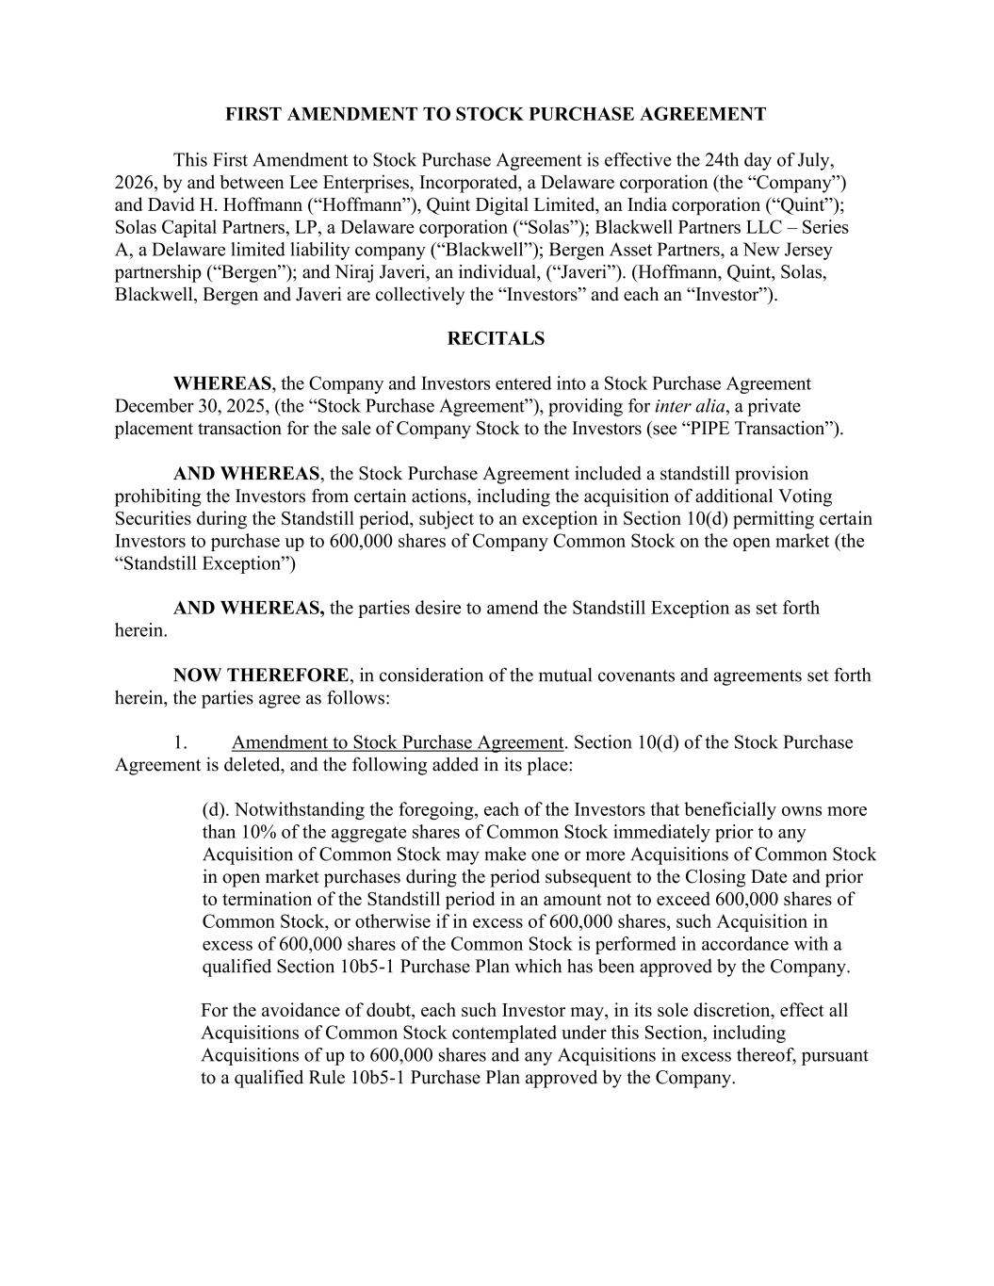

FIRST AMENDMENT TO STOCK PURCHASE AGREEMENT This First Amendment to Stock Purchase Agreement is effective the 24th day of July, 2026, by and between Lee Enterprises, Incorporated, a Delaware corporation (the “Company”) and David H. Hoffmann (“Hoffmann”), Quint Digital Limited, an India corporation (“Quint”); Solas Capital Partners, LP, a Delaware corporation (“Solas”); Blackwell Partners LLC – Series A, a Delaware limited liability company (“Blackwell”); Bergen Asset Partners, a New Jersey partnership (“Bergen”); and Niraj Javeri, an individual, (“Javeri”). (Hoffmann, Quint, Solas, Blackwell, Bergen and Javeri are collectively the “Investors” and each an “Investor”). RECITALS WHEREAS, the Company and Investors entered into a Stock Purchase Agreement December 30, 2025, (the “Stock Purchase Agreement”), providing for inter alia, a private placement transaction for the sale of Company Stock to the Investors (see “PIPE Transaction”). AND WHEREAS, the Stock Purchase Agreement included a standstill provision prohibiting the Investors from certain actions, including the acquisition of additional Voting Securities during the Standstill period, subject to an exception in Section 10(d) permitting certain Investors to purchase up to 600,000 shares of Company Common Stock on the open market (the “Standstill Exception”) AND WHEREAS, the parties desire to amend the Standstill Exception as set forth herein. NOW THEREFORE, in consideration of the mutual covenants and agreements set forth herein, the parties agree as follows: 1. Amendment to Stock Purchase Agreement. Section 10(d) of the Stock Purchase Agreement is deleted, and the following added in its place: (d). Notwithstanding the foregoing, each of the Investors that beneficially owns more than 10% of the aggregate shares of Common Stock immediately prior to any Acquisition of Common Stock may make one or more Acquisitions of Common Stock in open market purchases during the period subsequent to the Closing Date and prior to termination of the Standstill period in an amount not to exceed 600,000 shares of Common Stock, or otherwise if in excess of 600,000 shares, such Acquisition in excess of 600,000 shares of the Common Stock is performed in accordance with a qualified Section 10b5-1 Purchase Plan which has been approved by the Company. For the avoidance of doubt, each such Investor may, in its sole discretion, effect all Acquisitions of Common Stock contemplated under this Section, including Acquisitions of up to 600,000 shares and any Acquisitions in excess thereof, pursuant to a qualified Rule 10b5-1 Purchase Plan approved by the Company.

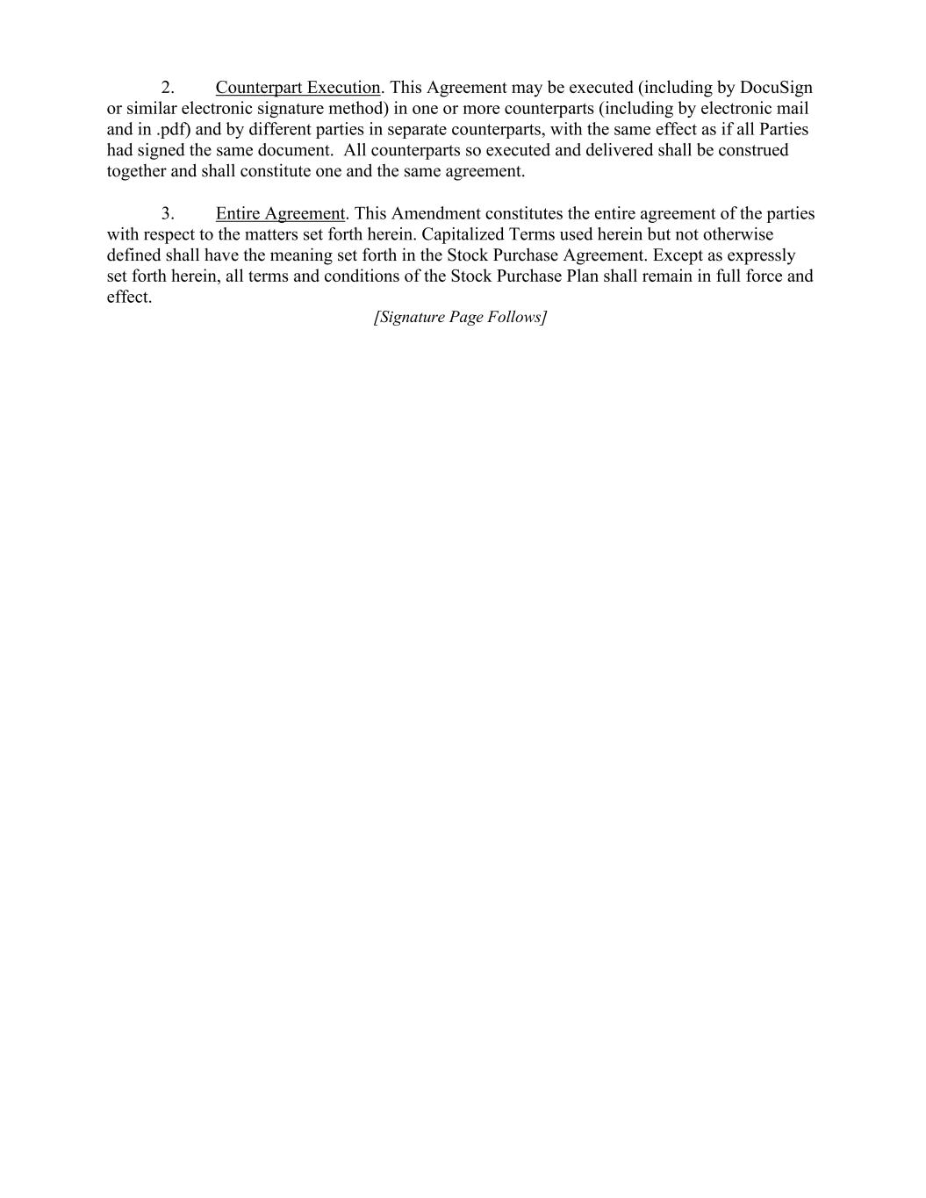
2. Counterpart Execution. This Agreement may be executed (including by DocuSign or similar electronic signature method) in one or more counterparts (including by electronic mail and in .pdf) and by different parties in separate counterparts, with the same effect as if all Parties had signed the same document. All counterparts so executed and delivered shall be construed together and shall constitute one and the same agreement. 3. Entire Agreement. This Amendment constitutes the entire agreement of the parties with respect to the matters set forth herein. Capitalized Terms used herein but not otherwise defined shall have the meaning set forth in the Stock Purchase Agreement. Except as expressly set forth herein, all terms and conditions of the Stock Purchase Plan shall remain in full force and effect. [Signature Page Follows]

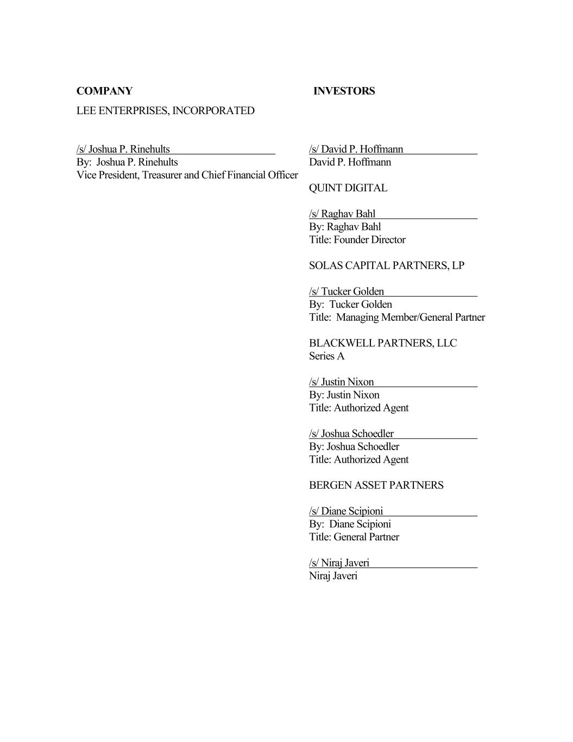
COMPANY INVESTORS LEE ENTERPRISES, INCORPORATED /s/ Joshua P. Rinehults /s/ David P. Hoffmann By: Joshua P. Rinehults David P. Hoffmann Vice President, Treasurer and Chief Financial Officer QUINT DIGITAL /s/ Raghav Bahl By: Raghav Bahl Title: Founder Director SOLAS CAPITAL PARTNERS, LP /s/ Tucker Golden By: Tucker Golden Title: Managing Member/General Partner BLACKWELL PARTNERS, LLC Series A /s/ Justin Nixon By: Justin Nixon Title: Authorized Agent /s/ Joshua Schoedler By: Joshua Schoedler Title: Authorized Agent BERGEN ASSET PARTNERS /s/ Diane Scipioni By: Diane Scipioni Title: General Partner /s/ Niraj Javeri Niraj Javeri

