UNITED STATES
SECURITIES AND EXCHANGE COMMISSION
Washington, D.C. 20549
FORM 8-K
CURRENT REPORT
PURSUANT TO SECTION 13 OR 15(d) OF THE
SECURITIES EXCHANGE ACT OF 1934
Date of Report (Date of earliest event reported): August 6, 2026
_______________________________________________________________________________________
LEE ENTERPRISES, INCORPORATED
(Exact name of Registrant as specified in its charter)
_______________________________________________________________________________________
Delaware |  |  | 1-6227 |  |  | 42-0823980
(State of Incorporation) |  |  | (Commission File Number) |  |  | (I.R.S. Employer Identification No.)
 |  |  | 4600 E. 53rd Street, Davenport, Iowa 52807
 |  |  | (Address of Principal Executive Offices)
 |  |  | (563) 383-2100
 |  |  | Registrant’s telephone number, including area code
Securities registered pursuant to Section 12(b) of the Act:
Title of each class |  |  | Trading Symbol(s) |  |  | Name of each exchange on which registered
Common Stock, par value $.01 per share |  |  | LEE |  |  | The Nasdaq Global Select Market
Check the appropriate box below if the Form 8-K filing is intended to simultaneously satisfy the filing obligation of the registrant under any of the following provisions:
o |  |  | Written communications pursuant to Rule 425 under the Securities Act (17 CFR 230.425)
o |  |  | Soliciting material pursuant to Rule 14a-12 under the Exchange Act (17 CFR 240.14a-12)
o |  |  | Pre-commencement communications pursuant to Rule 14d-2(b) under the Exchange Act (17 CFR 240.14d-2(b))
o |  |  | Pre-commencement communications pursuant to Rule 13e-4(c) under the Exchange Act (17 CFR 240.13e-4(c))
Indicate by check mark whether the Registrant is an emerging growth company as defined in Rule 405 of the Securities Act of 1933 (§230.405 of this chapter) or Rule 12b-2 of the Securities Exchange Act of 1934 (§240.12b-2 of this chapter).
Emerging growth company o
If an emerging growth company, indicate by check mark if the Registrant has elected not to use the extended transition period for complying with any new or revised financial accounting standards provided pursuant to Section 13(a) of the Exchange Act. o

Item 2.02. Results of Operations and Financial Condition.
On August 6, 2026, Lee Enterprises, Incorporated (the “Company”) reported its preliminary results for the third quarter ended June 28, 2026. In connection with the preliminary results, the Company issued an earnings release, which is attached hereto as Exhibit 99.1 (“Earnings Release”). The Company also prepared presentation materials which were presented by management during the Company’s earnings conference call, which are attached hereto as Exhibit 99.2 and have been made available on the Company’s website, investors.lee.net (“Presentation Materials”). In addition to the information in the Earnings Release, the Presentation Materials include content and financial figures demonstrating the Company’s expectation to be sustainable without reliance on print media as a long-term objective.
The information furnished by and incorporated by reference in this Item 2.02, including the attached Exhibits, shall not be deemed filed for purposes of Section 18 of the Securities Exchange Act of 1934, as amended, nor shall it be deemed incorporated by reference in any filing under the Securities Act of 1933, as amended, except as shall be expressly set forth by specific reference in such filing.

Item 7.01. Regulation FD Disclosure
The disclosure contained in Item 2.02 is incorporated herein by reference.

Item 9.01. Financial Statements and Exhibits.
 |  |  | (d)Exhibits
 |  |  | 99.1 |  |  | Earnings Release
 |  |  | 99.2 |  |  | Presentation Materials
 |  |  | 104 |  |  | Cover Page Interactive Data File (embedded within the Inline XBRL document)

SIGNATURES
Pursuant to the requirements of the Securities Exchange Act of 1934, the Registrant has duly caused this report to be signed on its behalf by the undersigned thereunto duly authorized.
 |  |  |  |  |  |  |  |  |  |  |  | LEE ENTERPRISES, INCORPORATED
Date: |  |  | August 6, 2026 |  |  |  |  |  | By: |  |  | /s/ Joshua P. Rinehults
 |  |  |  |  |  |  |  |  |  |  |  | Joshua P. Rinehults
 |  |  |  |  |  |  |  |  |  |  |  | Vice President, Interim Chief Financial Officer and Treasurer


Lee Enterprises Reports Strong Third Quarter Results and Increases 2026 Fiscal Year Outlook

Delivered Net Income of $5 million
23% YOY Adjusted EBITDA(1) growth in Q3
Digital revenue(2) represents 57% of total revenue in Q3
Ended Q3 with $59 million in cash
Increased fiscal 2026 Adjusted EBITDA(1) outlook

DAVENPORT, Iowa (August 6, 2026) — Lee Enterprises, Incorporated (NASDAQ: LEE), a digital-first subscription platform providing high quality, trusted, local news, information and a major platform for advertising in 114 markets, today reported preliminary third quarter fiscal 2026 financial results(3) for the period ended June 28, 2026.

"Our third quarter results demonstrate the continued execution of our digital-first strategy and the meaningful progress we are making across the business," said Nathan Bekke, Lee's President and Chief Executive Officer. "We delivered another quarter of year-over-year Adjusted EBITDA growth while generating positive net income, reflecting disciplined cost management, ongoing operational improvements and the benefits of the strategic actions we've taken over the past year. Third quarter Adjusted EBITDA increased 23% year-over-year, or 19% excluding insurance reimbursements received. These results underscore the strength of our operating model and reinforce our confidence in the direction of the business."

“Based on our performance through the first nine months of the fiscal year and continued confidence in our operating momentum, we are increasing our outlook for fiscal 2026 Adjusted EBITDA,” added Bekke. “We now expect to finish the year with year-over-year growth between 22% and 28%. Excluding the insurance proceeds received this year related to last year’s cyber event, that still translates to year-over-year Adjusted EBITDA growth near 10%. The updated outlook reflects continued execution of our strategy, sustained operational discipline, and confidence in continued profitability through the remainder of the fiscal year.”

"Our return to positive net income reflects the progress we've made in strengthening the business and improving our financial foundation," added Josh Rinehults, Lee's Vice President, Chief Financial Officer and Treasurer. "Net income in the quarter was driven by continued Adjusted EBITDA growth and lower interest expense following February's strategic investment. Interest expense declined 45%, or $5 million, from the prior-year quarter, reflecting the reduction in our interest rate from 9% to 5%. We also ended the quarter with $59 million in cash on our balance sheet, providing additional flexibility as we continue to invest in our digital transformation while maintaining a disciplined approach to capital allocation."

"Our operational focus remains centered on improving profitability while continuing to invest in the products, technology and journalism that support long-term digital growth," Bekke added. "Throughout the quarter, we continued to optimize our workflows and align resources with the evolving needs of our business. These initiatives are driving greater efficiency, supporting margin expansion and positioning Lee to operate with increased scale as our digital business continues to evolve."

"During the quarter, we also announced a new management agreement with Hoffmann Media Group," Bekke continued. "This partnership highlights the value of Lee's operating platform, digital expertise and deep experience serving local markets. As we assume management responsibilities, we have the opportunity to further leverage our technology, operational capabilities and best practices while deepening a relationship that aligns with our long-term strategic objectives. We believe this agreement demonstrates the strength and scalability of our platform while creating opportunities for future growth for Lee."

"We remain focused on building a more resilient, scalable business that delivers sustainable long-term value," Bekke concluded. "We are encouraged by our performance through the first nine months of the fiscal year combined with the expansion of our operating platform which reinforces our confidence in the direction of the
1
business. We believe Lee is well positioned to continue driving long-term profitability and creating lasting value for our shareholders."

For the third quarter ended June 28, 2026:

•Total operating revenue was $126 million.

•Total Digital Revenue was $72 million and represented 57% of our total operating revenue.
•Revenue from digital-only subscribers totaled $22 million. Digital-only subscription revenue increased 12% annually over the past three years. Digital-only subscribers totaled 584,000 at the end of the quarter.
•Digital advertising and marketing services revenue represented 76% of our total advertising revenue and totaled $45 million. Amplified Digital® Agency revenue totaled $27 million in the quarter.
•Digital services revenue, which is predominantly from BLOX Digital, totaled $5 million.
•Total Print Revenue was $54 million.
•Operating expenses totaled $118 million and Cash Costs(1) totaled $109 million, representing 14% and 14% decreases compared to the prior year, respectively.
•Net income totaled $5 million, an improvement of $7 million over the prior year quarter.
•Adjusted EBITDA totaled $18 million, an increase of $3 million, or 23%, over the prior year quarter.

2026 Fiscal Year Outlook:
Adjusted EBITDA |  |  | 22% to 28% YOY growth

Debt and Free Cash Flow:
The Company has $455 million of debt outstanding under our Credit Agreement with BH Finance. The financing has favorable terms including a 25-year maturity, a fixed annual interest rate, no fixed principal payments, and no financial performance covenants. The $50 million private placement of common stock closed in February 2026 made operative certain amendments to the Credit Agreement with BH Finance, resulting in the fixed annual interest rate dropping to 5% from 9% for a five-year period(4).
As of and for the period ended June 28, 2026:
•The principal amount of debt totaled $455 million.
•Cash on the balance sheet totaled $59 million. Debt, net of cash on the balance sheet, totaled $395 million.
•Capital expenditures totaled $1 million for the quarter. We expect up to $7 million of capital expenditures in FY26.
•We expect cash paid for income taxes to total between $3 million and $9 million in FY26.
•We do not expect any pension contributions in the fiscal year.
•The Company is executing a strategic termination of our fully funded benefit pension plan, eliminating the long-term volatility tied to interest rate movement, mortality assumptions and asset performance, while preserving participant benefits and improving balance sheet flexibility.
Conference Call Information:
As previously announced, we will hold an earnings conference call and audio webcast today at 9 a.m. Central Time. The live webcast will be accessible at www.lee.net and will be available for replay 24 hours later. Questions from other participants may be submitted by participating in the webcast. To participate in the live
2
conference call via telephone, please register at www.lee.net. Upon registering, a dial-in number and unique PIN will be provided to join the conference call.

About Lee:
Lee Enterprises is a leading provider of local news and information and a major subscription and advertising platform, with daily and weekly newspapers and rapidly expanding digital products serving 114 markets across 25 states. Lee's markets include St. Louis, MO; Buffalo, NY; Omaha, NE; Richmond, VA; Lincoln, NE; Madison, WI; Davenport, IA; and Tucson, AZ. Lee Common Stock is traded on NASDAQ under the symbol LEE. For more information about Lee, please visit www.lee.net.
FORWARD-LOOKING STATEMENTS — The Private Securities Litigation Reform Act of 1995 provides a “safe harbor” for forward-looking statements. This release contains information that may be deemed forward-looking that is based largely on our current expectations, and is subject to certain risks, trends and uncertainties that could cause actual results to differ materially from those anticipated. Among such risks, trends and other uncertainties, which in some instances are beyond our control, are:

•Our ability to manage declining print revenue and circulation subscribers;
•The impact and duration of adverse conditions in certain aspects of the economy affecting our business;
•Changes in advertising and subscription demand;
•Changes in technology that impact our ability to deliver digital advertising;
•Potential changes in newsprint, other commodities and energy costs;
•Interest rates;
•Labor costs;
•Significant cyber security breaches or failure of our information technology systems;
•Our ability to achieve planned expense reductions and realize the expected benefit of our acquisitions;
•Our ability to maintain employee and customer relationships;
•Our ability to manage increased capital costs;
•Our ability to maintain our listing status on NASDAQ;
•Competition;
•We may be required to indemnify the previous owners of BH Media or The Buffalo News for unknown legal and other matters that may arise;
•The impacts of changes to our leadership and corporate governance; and
•Other risks detailed from time to time in our publicly filed documents.
Any statements that are not statements of historical fact (including statements containing the words “may”, “will”, “would”, “could”, “believes”, “expects”, “anticipates”, “intends”, “plans”, “projects”, “considers” and similar expressions) generally should be considered forward-looking statements. Statements regarding our plans, strategies, prospects and expectations regarding our business and industry and our responses thereto may have on our future operations, are forward-looking statements. They reflect our expectations, are not guarantees of performance and speak only as of the date the statement is made. Readers are cautioned not to place undue reliance on such forward-looking statements, which are made as of the date of this report. We do not undertake to publicly update or revise our forward-looking statements, except as required by law.
Contact:
IR@lee.net
(563) 383-2100

3
CONSOLIDATED STATEMENTS OF OPERATIONS
(UNAUDITED)

 |  |  | Three months ended |  |  |  |  |  | Nine months ended
(Thousands of Dollars, Except Per Common Share Data) |  |  | June 28,  2026 |  |  | June 29,  2025 |  |  | June 28,  2026 |  |  | June 29,  2025
Operating revenue:
Print advertising revenue |  |  | 14,478 |  |  | 17,474 |  |  | 45,943 |  |  | 53,867
Digital advertising revenue |  |  | 44,846 |  |  | 49,097 |  |  | 128,334 |  |  | 139,766
Advertising and marketing services revenue |  |  | 59,324 |  |  | 66,571 |  |  | 174,277 |  |  | 193,633
Print subscription revenue |  |  | 32,918 |  |  | 38,076 |  |  | 100,816 |  |  | 122,587
Digital subscription revenue |  |  | 21,829 |  |  | 23,482 |  |  | 66,814 |  |  | 68,836
Subscription revenue |  |  | 54,747 |  |  | 61,558 |  |  | 167,630 |  |  | 191,423
Print other revenue |  |  | 6,967 |  |  | 7,837 |  |  | 21,545 |  |  | 22,938
Digital other revenue |  |  | 4,932 |  |  | 5,328 |  |  | 14,544 |  |  | 15,241
Other revenue |  |  | 11,899 |  |  | 13,165 |  |  | 36,089 |  |  | 38,179
Total operating revenue |  |  | 125,970 |  |  | 141,294 |  |  | 377,996 |  |  | 423,235
Operating expenses:
Compensation |  |  | 44,810 |  |  | 47,436 |  |  | 140,989 |  |  | 164,349
Newsprint and ink |  |  | 2,521 |  |  | 3,268 |  |  | 8,005 |  |  | 9,996
Other operating expenses |  |  | 62,076 |  |  | 77,252 |  |  | 193,640 |  |  | 223,387
Insurance proceeds |  |  | (560) |  |  | — |  |  | (6,401) |  |  | —
Depreciation and amortization |  |  | 3,527 |  |  | 3,783 |  |  | 10,621 |  |  | 15,218
Gain on asset sales, impairments and other, net |  |  | (73) |  |  | (1,562) |  |  | (976) |  |  | (2,365)
Restructuring costs and other |  |  | 5,959 |  |  | 7,141 |  |  | 12,746 |  |  | 18,806
Total operating expenses |  |  | 118,260 |  |  | 137,318 |  |  | 358,624 |  |  | 429,391
Equity in earnings of associated companies |  |  | 922 |  |  | 686 |  |  | 3,010 |  |  | 2,963
Operating income (loss) |  |  | 8,632 |  |  | 4,662 |  |  | 22,382 |  |  | (3,193)
Non-operating (expense) income:
Interest expense |  |  | (5,558) |  |  | (10,132) |  |  | (23,435) |  |  | (30,365)
Pension and other post employment benefits ("OPEB") related and other, net |  |  | 1,169 |  |  | 1,050 |  |  | 2,840 |  |  | 2,362
Settlement gains |  |  | 2,330 |  |  | — |  |  | 2,330 |  |  | —
Total non-operating expense, net |  |  | (2,059) |  |  | (9,082) |  |  | (18,265) |  |  | (28,003)
Income (loss) before income taxes |  |  | 6,573 |  |  | (4,420) |  |  | 4,117 |  |  | (31,196)
Income tax expense (benefit) |  |  | 1,400 |  |  | (2,744) |  |  | 5,779 |  |  | (1,281)
Net income (loss) |  |  | 5,173 |  |  | (1,676) |  |  | (1,662) |  |  | (29,915)
Net income attributable to non-controlling interests |  |  | (498) |  |  | (244) |  |  | (1,423) |  |  | (1,264)
Income (loss) attributable to Lee Enterprises, Incorporated |  |  | 4,675 |  |  | (1,920) |  |  | (3,085) |  |  | (31,179)
Other comprehensive loss, net of income taxes |  |  | (1,611) |  |  | (115) |  |  | (1,769) |  |  | (230)
Comprehensive income (loss) attributable to Lee Enterprises, Incorporated |  |  | 3,064 |  |  | (2,035) |  |  | (4,854) |  |  | (31,409)
Earnings (loss) per common share:
Basic: |  |  | 0.21 |  |  | (0.31) |  |  | (0.22) |  |  | (5.16)
Diluted: |  |  | 0.21 |  |  | (0.31) |  |  | (0.22) |  |  | (5.16)

4
DIGITAL / PRINT REVENUE COMPOSITION
(UNAUDITED)
 |  |  | Three months Ended |  |  |  |  |  | Nine months ended
(Thousands of Dollars) |  |  | June 28,  2026 |  |  | June 29,  2025 |  |  | June 28,  2026 |  |  | June 29,  2025
Digital Advertising and Marketing Services Revenue |  |  | 44,846 |  |  | 49,097 |  |  | 128,334 |  |  | 139,766
Digital Only Subscription Revenue |  |  | 21,829 |  |  | 23,482 |  |  | 66,814 |  |  | 68,836
Digital Services Revenue |  |  | 4,932 |  |  | 5,328 |  |  | 14,544 |  |  | 15,241
Total Digital Revenue |  |  | 71,607 |  |  | 77,907 |  |  | 209,692 |  |  | 223,843
Print Advertising Revenue |  |  | 14,478 |  |  | 17,474 |  |  | 45,943 |  |  | 53,867
Print Subscription Revenue |  |  | 32,918 |  |  | 38,076 |  |  | 100,816 |  |  | 122,587
Other Print Revenue |  |  | 6,967 |  |  | 7,837 |  |  | 21,545 |  |  | 22,938
Total Print Revenue |  |  | 54,363 |  |  | 63,387 |  |  | 168,304 |  |  | 199,392
Total Operating Revenue |  |  | 125,970 |  |  | 141,294 |  |  | 377,996 |  |  | 423,235

5
RECONCILIATION OF NON-GAAP FINANCIAL MEASURES
(UNAUDITED)
The tables below reconcile the non-GAAP financial performance measure of Adjusted EBITDA to Net loss, its most directly comparable U.S. GAAP measure:
 |  |  | Three months ended |  |  |  |  |  | Nine months ended
(Thousands of Dollars) |  |  | June 28, 2026 |  |  | June 29, 2025 |  |  | June 28, 2026 |  |  | June 29, 2025
Net income (loss) |  |  | 5,173 |  |  | (1,676) |  |  | (1,662) |  |  | (29,915)
Adjusted to exclude
Income tax expense (benefit) |  |  | 1,400 |  |  | (2,744) |  |  | 5,779 |  |  | (1,281)
Non-operating expenses, net |  |  | 2,059 |  |  | 9,082 |  |  | 18,265 |  |  | 28,003
Equity in earnings of TNI and MNI |  |  | (922) |  |  | (686) |  |  | (3,010) |  |  | (2,963)
Depreciation and amortization |  |  | 3,527 |  |  | 3,783 |  |  | 10,621 |  |  | 15,218
Restructuring costs and other |  |  | 5,959 |  |  | 7,141 |  |  | 12,746 |  |  | 18,806
Gain on asset sales, impairments and other, net |  |  | (73) |  |  | (1,562) |  |  | (976) |  |  | (2,365)
Stock compensation |  |  | 181 |  |  | 540 |  |  | 722 |  |  | 1,328
Add:
Ownership share of TNI and MNI EBITDA (50%) |  |  | 1,071 |  |  | 1,066 |  |  | 3,296 |  |  | 3,488
Adjusted EBITDA |  |  | 18,375 |  |  | 14,944 |  |  | 45,781 |  |  | 30,319

The table below reconciles the non-GAAP financial performance measure of Cash Costs to Operating expenses, the most directly comparable U.S. GAAP measure:
 |  |  | Three months ended |  |  |  |  |  | Nine months ended
(Thousands of Dollars) |  |  | June 28, 2026 |  |  | June 29, 2025 |  |  | June 28, 2026 |  |  | June 29, 2025
Operating expenses |  |  | 118,260 |  |  | 137,318 |  |  | 358,624 |  |  | 429,391
Adjustments
Depreciation and amortization |  |  | 3,527 |  |  | 3,783 |  |  | 10,621 |  |  | 15,218
Gain on asset sales, impairments and other, net |  |  | (73) |  |  | (1,562) |  |  | (976) |  |  | (2,365)
Restructuring costs and other |  |  | 5,959 |  |  | 7,141 |  |  | 12,746 |  |  | 18,806
Insurance proceeds |  |  | (560) |  |  | — |  |  | (6,401) |  |  | —
Cash Costs |  |  | 109,407 |  |  | 127,956 |  |  | 342,634 |  |  | 397,732
6
The table below reconciles the non-GAAP financial performance measure of Same-store Revenues to Operating Revenues, its most directly comparable U.S. GAAP measure:
 |  |  | Three months ended |  |  |  |  |  | Nine months ended
(Thousands of Dollars) |  |  | June 28, 2026 |  |  | June 29, 2025 |  |  | June 28, 2026 |  |  | June 29, 2025
Print Advertising Revenue |  |  | 14,478 |  |  | 17,474 |  |  | 45,943 |  |  | 53,867
Exited operations |  |  | — |  |  | (2,189) |  |  | (2,399) |  |  | (6,676)
Same-store, Print Advertising Revenue |  |  | 14,478 |  |  | 15,285 |  |  | 43,544 |  |  | 47,191
Digital Advertising Revenue |  |  | 44,846 |  |  | 49,097 |  |  | 128,334 |  |  | 139,766
Exited operations |  |  | — |  |  | (1,144) |  |  | (770) |  |  | (4,204)
Same-store, Digital Advertising Revenue |  |  | 44,846 |  |  | 47,953 |  |  | 127,564 |  |  | 135,562
Total Advertising Revenue |  |  | 59,324 |  |  | 66,571 |  |  | 174,277 |  |  | 193,633
Exited operations |  |  | — |  |  | (3,333) |  |  | (3,169) |  |  | (10,880)
Same-store, Total Advertising Revenue |  |  | 59,324 |  |  | 63,238 |  |  | 171,108 |  |  | 182,753
Print Subscription Revenue |  |  | 32,918 |  |  | 38,076 |  |  | 100,816 |  |  | 122,587
Exited operations |  |  | — |  |  | (34) |  |  | (3) |  |  | (142)
Same-store, Print Subscription Revenue |  |  | 32,918 |  |  | 38,042 |  |  | 100,813 |  |  | 122,445
Digital Subscription Revenue |  |  | 21,829 |  |  | 23,482 |  |  | 66,814 |  |  | 68,836
Exited operations |  |  | — |  |  | — |  |  | — |  |  | (2)
Same-store, Digital Subscription Revenue |  |  | 21,829 |  |  | 23,482 |  |  | 66,814 |  |  | 68,834
Total Subscription Revenue |  |  | 54,747 |  |  | 61,558 |  |  | 167,630 |  |  | 191,423
Exited operations |  |  | — |  |  | (34) |  |  | (3) |  |  | (144)
Same-store, Total Subscription Revenue |  |  | 54,747 |  |  | 61,524 |  |  | 167,627 |  |  | 191,279
Print Other Revenue |  |  | 6,967 |  |  | 7,837 |  |  | 21,545 |  |  | 22,938
Exited operations |  |  | — |  |  | — |  |  | — |  |  | —
Same-store, Print Other Revenue |  |  | 6,967 |  |  | 7,837 |  |  | 21,545 |  |  | 22,938
Digital Other Revenue |  |  | 4,932 |  |  | 5,328 |  |  | 14,544 |  |  | 15,241
Exited operations |  |  | — |  |  | — |  |  | — |  |  | —
Same-store, Digital Other Revenue |  |  | 4,932 |  |  | 5,328 |  |  | 14,544 |  |  | 15,241
Total Other Revenue |  |  | 11,899 |  |  | 13,165 |  |  | 36,089 |  |  | 38,179
Exited operations |  |  | — |  |  | — |  |  | — |  |  | —
Same-store, Total Other Revenue |  |  | 11,899 |  |  | 13,165 |  |  | 36,089 |  |  | 38,179
Total Operating Revenue |  |  | 125,970 |  |  | 141,294 |  |  | 377,996 |  |  | 423,235
Exited operations |  |  | — |  |  | (3,367) |  |  | (3,172) |  |  | (11,024)
Same-store, Total Operating Revenue |  |  | 125,970 |  |  | 137,927 |  |  | 374,824 |  |  | 412,211

7
NOTES
(1)The following are non-GAAP (Generally Accepted Accounting Principles) financial measures for which reconciliations to relevant U.S GAAP measures are included in tables accompanying this release:
•Adjusted EBITDA is a non-GAAP financial performance measure that enhances financial statement users overall understanding of the operating performance of the Company. The measure isolates unusual, infrequent or non-cash transactions from the operating performance of the business. This allows users to easily compare operating performance among various fiscal periods and how management measures the performance of the business. This measure also provides users with a benchmark that can be used when forecasting future operating performance of the Company that excludes unusual, nonrecurring or one-time transactions. Adjusted EBITDA is a component of the calculation used by stockholders and analysts to determine the value of our business when using the market approach, which applies a market multiple to financial metrics. It is also a measure used to calculate the leverage ratio of the Company, which is a key financial ratio monitored and used by the Company and its investors. Adjusted EBITDA is defined as net income (loss), plus non-operating expenses, income tax expense, depreciation and amortization, assets loss (gain) on sales, impairments and other, restructuring costs and other, stock compensation and our 50% share of EBITDA from TNI and MNI, minus equity in earnings of TNI and MNI.
•Cash Costs represent a non-GAAP financial performance measure of operating expenses which are measured on an accrual basis and settled in cash. This measure is useful to investors in understanding the components of the Company’s cash-settled operating costs. Periodically, the Company provides forward-looking guidance of Cash Costs, which can be used by financial statement users to assess the Company's ability to manage and control its operating cost structure. Cash Costs are defined as compensation, newsprint and ink and other operating expenses. Depreciation and amortization, assets loss (gain) on sales, impairments and other, other non-cash operating expenses and other expenses are excluded. Cash Costs also exclude restructuring costs and other, which are typically paid in cash.
(2)Total Digital Revenue is defined as digital advertising and marketing services revenue (including Amplified Digital®), digital-only subscription revenue and digital services revenue.
(3)This earnings release is a preliminary report of results for the periods included. The reader should refer to the Company's most recent reports on Form 10-Q and on Form 10-K for definitive information.
(4)The Company's current debt balance is $455 million, reflecting the outstanding balance of the $576 million term loan originally incurred under the credit agreement with BH Finance LLC dated January 29, 2020 (the "Credit Agreement"). Excess Cash Flow was previously defined under the Credit Agreement as any cash greater than $20.0 million on the balance sheet in accordance with U.S. GAAP at the end of each fiscal quarter, beginning with the quarter ending June 28, 2020. Concurrently with the execution of the Stock Purchase Agreement, we entered into the Second Amendment to the Credit Agreement. The amendments set forth therein became operative upon the Company's receipt of the proceeds from the Private Placement at the Closing. The amendments include a reduction of the applicable margin on our 25-year term loan from 9% to 5% for a period of five years following the closing and amending the definition of Excess Cash Flow such that the minimum amount of cash on hand held by us before being deemed Excess Cash Flow would be equal to $64.0 million.
(5)Comparable basis is a non-GAAP performance measure based on U.S. GAAP trends for Lee for the current period, excluding the extra week in fiscal 2024. The fourth quarter and full year of fiscal 2025 consisted of 13 weeks and 52 weeks, respectively. The fourth quarter and full year of fiscal 2024 consisted of 14 weeks and 53 weeks, respectively.
(6)FY25 revenue and Adjusted EBITDA were materially impacted by a cyber incident in February 2025. The FY25 impact on revenue and Adjusted EBITDA was approximately $12M and $8M, respectively. These metrics exclude any potential reimbursement from cyber insurance carrier in FY25. For the
8
nine months ended June 28 2026, we received $6.4 million in business interruption reimbursements that were recorded on their own line in "Operating Expenses" and included in Adjusted EBITDA. The remaining business-interruption claims remain under review.
(7)TNI refers to TNI Partners publishing operations in Tucson, AZ. MNI refers to Madison Newspapers, Inc. publishing operations in Madison, WI.

9
THIRD QUARTER FY2026 EARNINGS AUGUST 6, 2026


2 SAFE HARBOR The information provided in this presentation may include forward-looking statements relating to future events or the future financial performance of the Company. Because such statements are subject to risks and uncertainties, actual results may differ materially from those expressed or implied by such forward-looking statements. Words such as “aims”, “anticipates,” “plans,” “expects,” “intends,” “will,” “potential,” “hope” and similar expressions are intended to identify forward-looking statements. These forward-looking statements are based upon current expectations of the Company and involve assumptions that may never materialize or may prove to be incorrect. Actual results and the timing of events could differ materially from those anticipated in such forward-looking statements as a result of various risks and uncertainties. Detailed information regarding factors that may cause actual results to differ materially from the results expressed or implied by statements relating to the Company may be found in the Company’s periodic filings with the Commission, including the factors described in the sections entitled “Risk Factors,” copies of which may be obtained from the SEC’s website at www.sec.gov. The Company does not undertake any obligation to update forward-looking statements contained in this presentation.


3 LEE ENTERPRISES: AT-A-GLANCE Breaking newsServing 114 local markets across the USIntensely local content Lee Enterprises is a leading provider of high quality, trusted, local news and information. Our robust local and national digital media and advertising platforms are the fastest growing in the industry. Today, as throughout our history, in every one of the communities we serve, no competitor can match the indispensable local news, information and advertising we deliver to huge audiences of all ages.

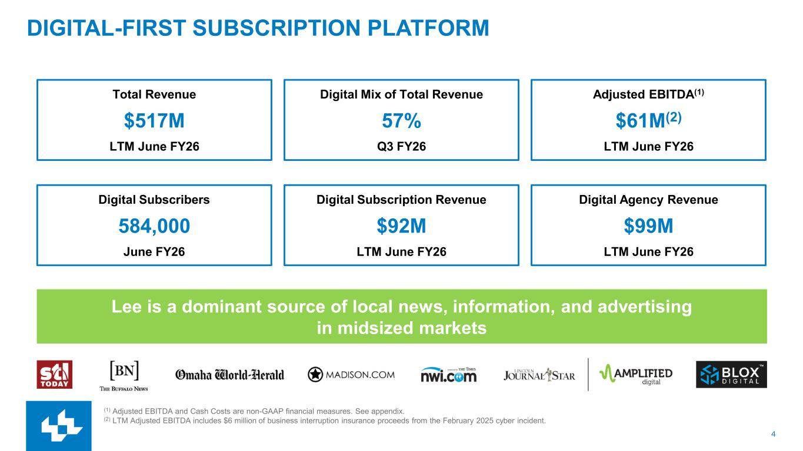
4 DIGITAL-FIRST SUBSCRIPTION PLATFORM Total Revenue $517M LTM June FY26 Digital Mix of Total Revenue 57% Q3 FY26 Adjusted EBITDA(1) $61M(2) LTM June FY26 Digital Subscribers 584,000 June FY26 Digital Subscription Revenue $92M LTM June FY26 Lee is a dominant source of local news, information, and advertising in midsized markets Digital Agency Revenue $99M LTM June FY26 (1) Adjusted EBITDA and Cash Costs are non-GAAP financial measures. See appendix. (2) LTM Adjusted EBITDA includes $6 million of business interruption insurance proceeds from the February 2025 cyber incident.

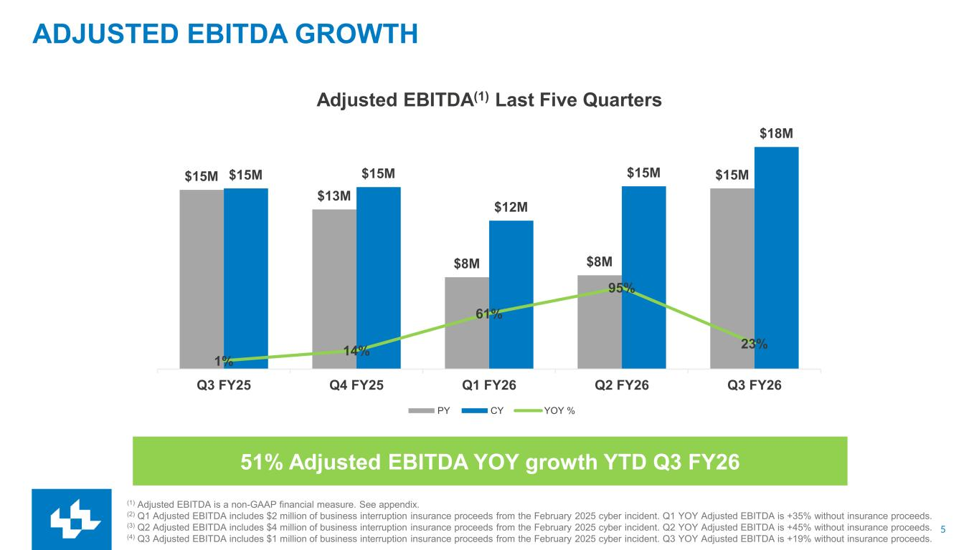
5 ADJUSTED EBITDA GROWTH (1) Adjusted EBITDA is a non-GAAP financial measure. See appendix. (2) Q1 Adjusted EBITDA includes $2 million of business interruption insurance proceeds from the February 2025 cyber incident. Q1 YOY Adjusted EBITDA is +35% without insurance proceeds. (3) Q2 Adjusted EBITDA includes $4 million of business interruption insurance proceeds from the February 2025 cyber incident. Q2 YOY Adjusted EBITDA is +45% without insurance proceeds. (4) Q3 Adjusted EBITDA includes $1 million of business interruption insurance proceeds from the February 2025 cyber incident. Q3 YOY Adjusted EBITDA is +19% without insurance proceeds. 51% Adjusted EBITDA YOY growth YTD Q3 FY26 $15M $13M $8M $8M $15M$15M $15M $12M $15M $18M 1% 14% 61% 95% 23% -10% 40% 90% 140% 190% 240% 290% - 2.0 4.0 6.0 8.0 10.0 12.0 14.0 16.0 18.0 20.0 Q3 FY25 Q4 FY25 Q1 FY26 Q2 FY26 Q3 FY26 Adjusted EBITDA(1) Last Five Quarters PY CY YOY %

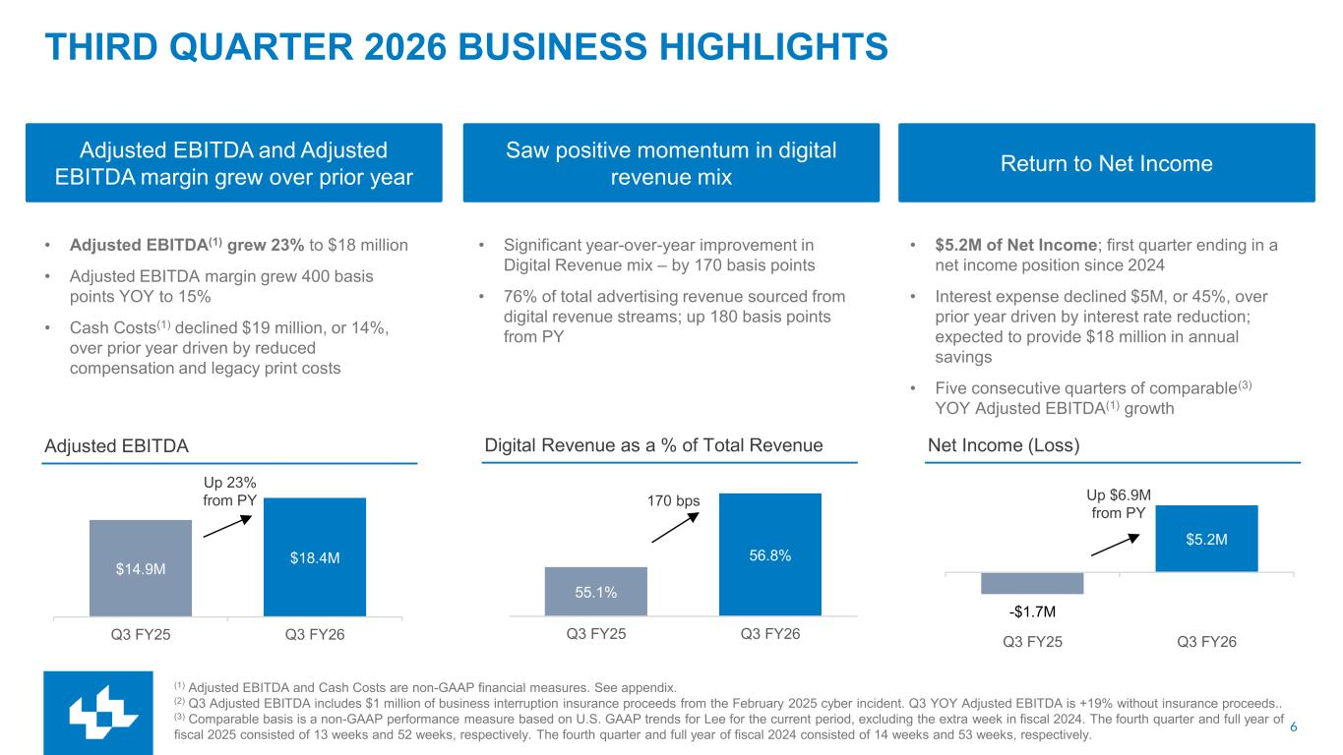
6 55.1% 56.8% Q3 FY25 Q3 FY26 $14.9M $18.4M Q3 FY25 Q3 FY26 THIRD QUARTER 2026 BUSINESS HIGHLIGHTS Adjusted EBITDA and Adjusted EBITDA margin grew over prior year • Adjusted EBITDA(1) grew 23% to $18 million • Adjusted EBITDA margin grew 400 basis points YOY to 15% • Cash Costs(1) declined $19 million, or 14%, over prior year driven by reduced compensation and legacy print costs Saw positive momentum in digital revenue mix Return to Net Income • Significant year-over-year improvement in Digital Revenue mix – by 170 basis points • 76% of total advertising revenue sourced from digital revenue streams; up 180 basis points from PY • $5.2M of Net Income; first quarter ending in a net income position since 2024 • Interest expense declined $5M, or 45%, over prior year driven by interest rate reduction; expected to provide $18 million in annual savings • Five consecutive quarters of comparable(3) YOY Adjusted EBITDA(1) growth (1) Adjusted EBITDA and Cash Costs are non-GAAP financial measures. See appendix. (2) Q3 Adjusted EBITDA includes $1 million of business interruption insurance proceeds from the February 2025 cyber incident. Q3 YOY Adjusted EBITDA is +19% without insurance proceeds.. (3) Comparable basis is a non-GAAP performance measure based on U.S. GAAP trends for Lee for the current period, excluding the extra week in fiscal 2024. The fourth quarter and full year of fiscal 2025 consisted of 13 weeks and 52 weeks, respectively. The fourth quarter and full year of fiscal 2024 consisted of 14 weeks and 53 weeks, respectively. Net Income (Loss)Digital Revenue as a % of Total RevenueAdjusted EBITDA Up 23% from PY 170 bps Up $6.9M from PY -$1.7M $5.2M Q3 FY25 Q3 FY26

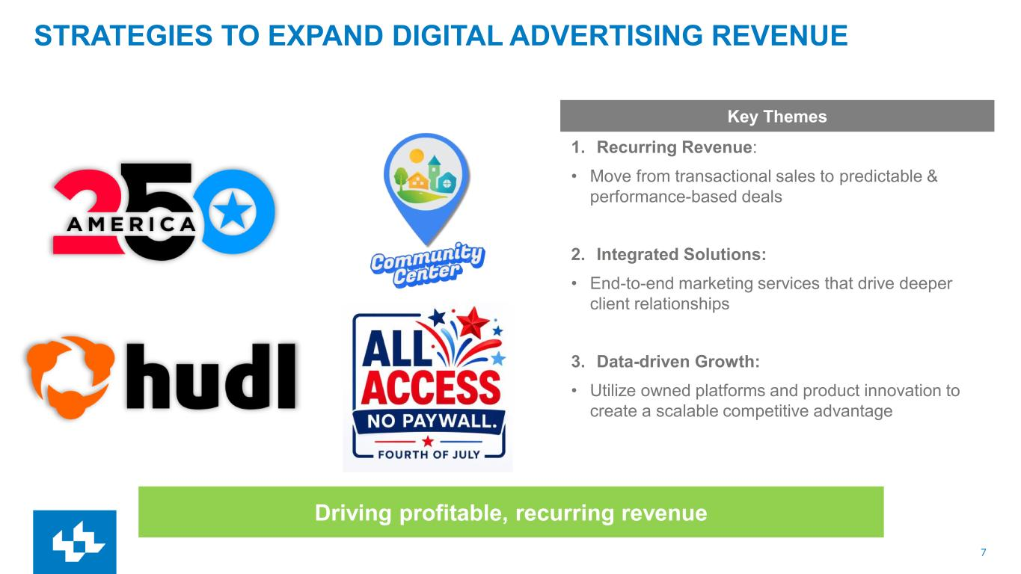
7 STRATEGIES TO EXPAND DIGITAL ADVERTISING REVENUE 1. Recurring Revenue: • Move from transactional sales to predictable & performance-based deals 2. Integrated Solutions: • End-to-end marketing services that drive deeper client relationships 3. Data-driven Growth: • Utilize owned platforms and product innovation to create a scalable competitive advantage Key Themes Driving profitable, recurring revenue

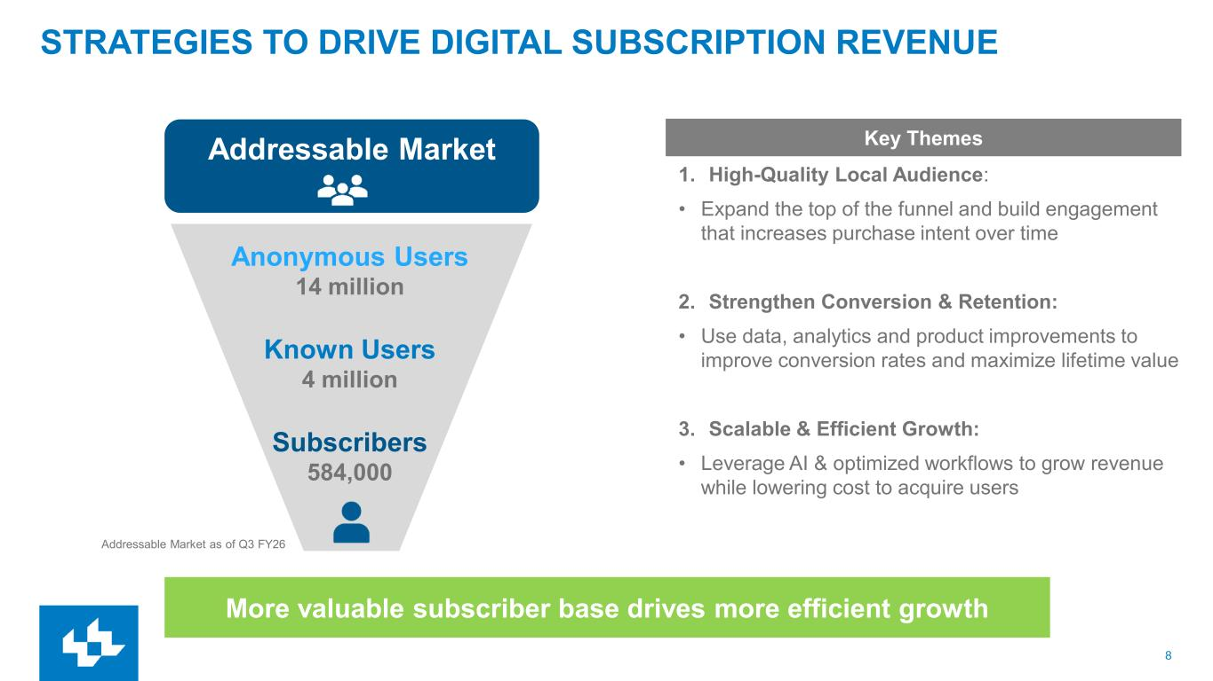
8 STRATEGIES TO DRIVE DIGITAL SUBSCRIPTION REVENUE Addressable Market Anonymous Users 14 million Known Users 4 million Subscribers 584,000 Addressable Market as of Q3 FY26 1. High-Quality Local Audience: • Expand the top of the funnel and build engagement that increases purchase intent over time 2. Strengthen Conversion & Retention: • Use data, analytics and product improvements to improve conversion rates and maximize lifetime value 3. Scalable & Efficient Growth: • Leverage AI & optimized workflows to grow revenue while lowering cost to acquire users Key Themes More valuable subscriber base drives more efficient growth

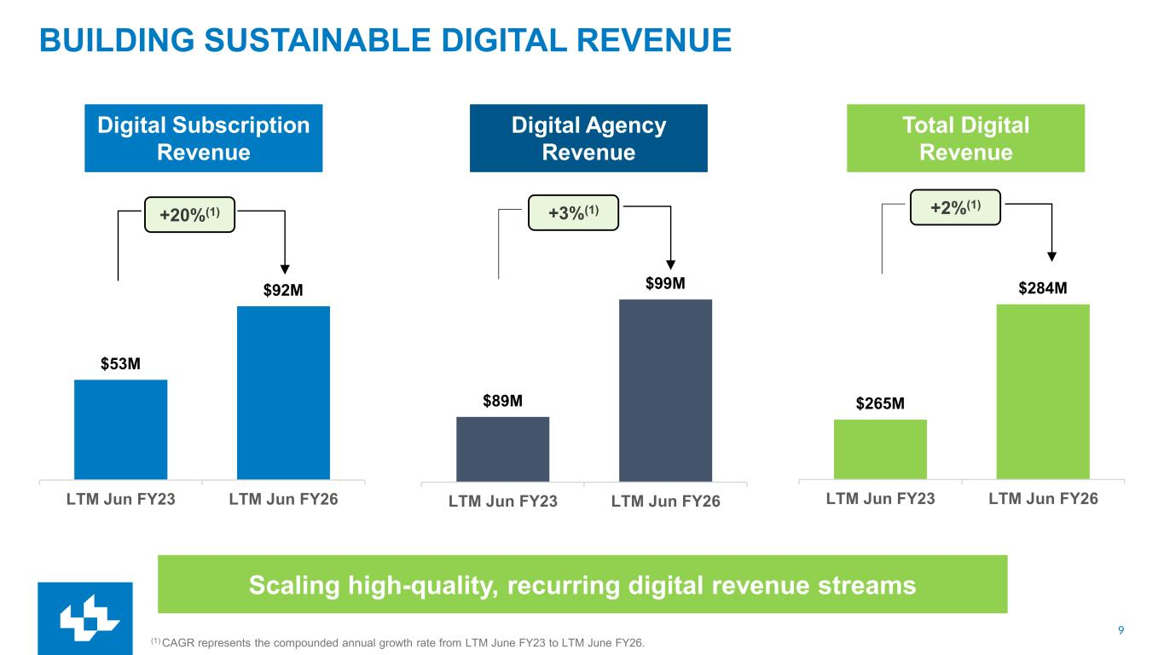
9 BUILDING SUSTAINABLE DIGITAL REVENUE (1) CAGR represents the compounded annual growth rate from LTM June FY23 to LTM June FY26. Scaling high-quality, recurring digital revenue streams Digital Subscription Revenue +20%(1) Digital Agency Revenue +3%(1) +2%(1) Total Digital Revenue $53M $92M LTM Jun FY23 LTM Jun FY26 $89M $99M LTM Jun FY23 LTM Jun FY26 $265M $284M LTM Jun FY23 LTM Jun FY26

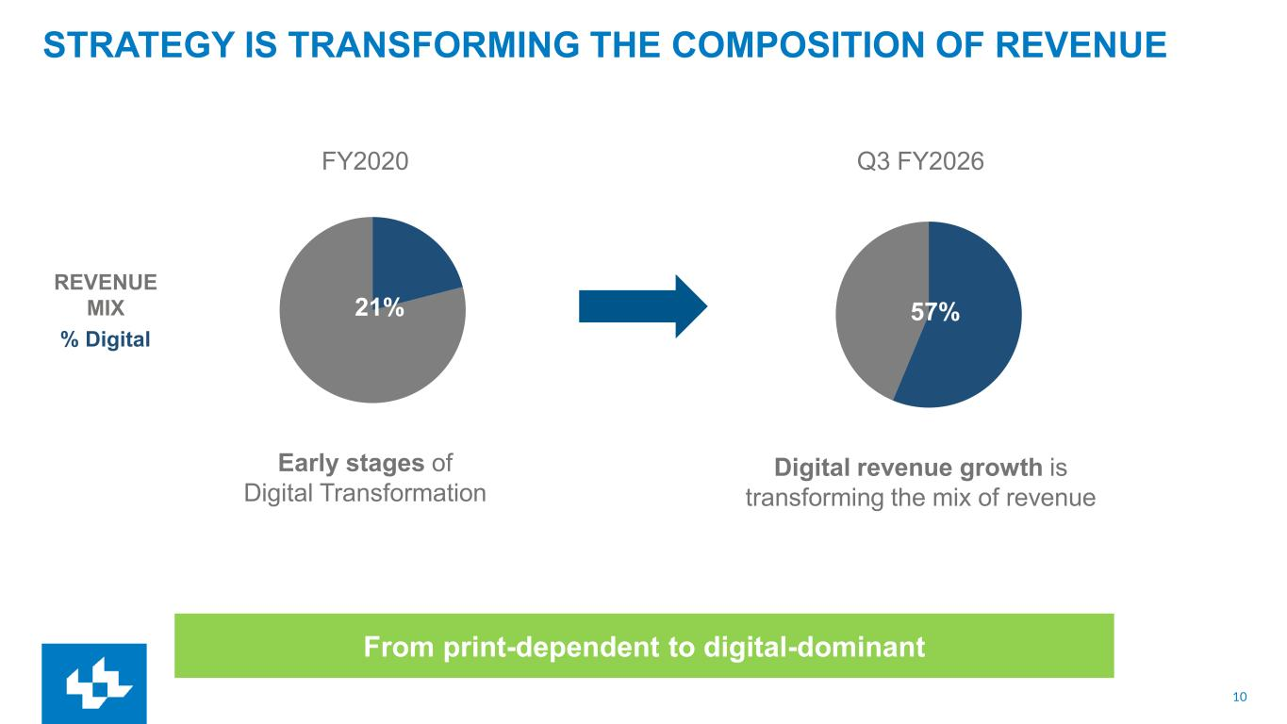
10 STRATEGY IS TRANSFORMING THE COMPOSITION OF REVENUE Early stages of Digital Transformation Digital revenue growth is transforming the mix of revenue FY2020 REVENUE MIX % Digital 7% 21% Q3 FY2026 57% From print-dependent to digital-dominant

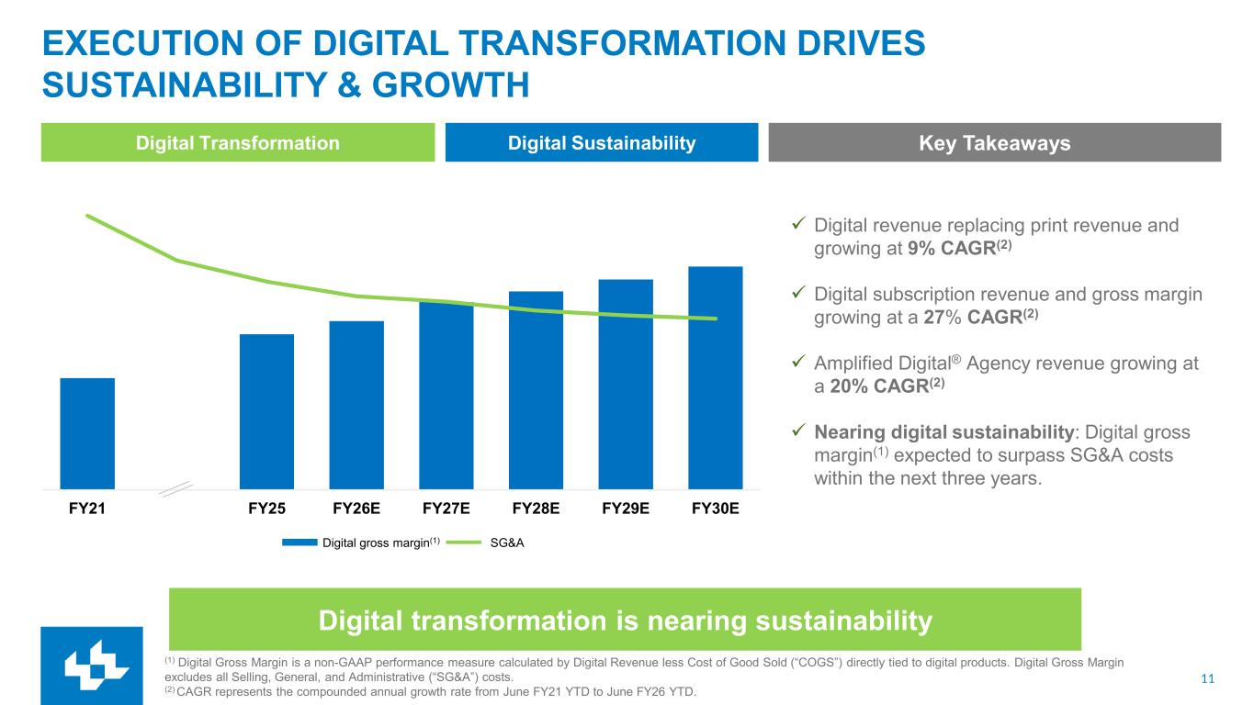
11 FY21 FY25 FY26E FY27E FY28E FY29E FY30E EXECUTION OF DIGITAL TRANSFORMATION DRIVES SUSTAINABILITY & GROWTH Digital Transformation Digital Sustainability Digital transformation is nearing sustainability Digital gross margin(1) SG&A Key Takeaways ✓ Digital revenue replacing print revenue and growing at 9% CAGR(2) ✓ Digital subscription revenue and gross margin growing at a 27% CAGR(2) ✓ Amplified Digital® Agency revenue growing at a 20% CAGR(2) ✓ Nearing digital sustainability: Digital gross margin(1) expected to surpass SG&A costs within the next three years. (1) Digital Gross Margin is a non-GAAP performance measure calculated by Digital Revenue less Cost of Good Sold (“COGS”) directly tied to digital products. Digital Gross Margin excludes all Selling, General, and Administrative (“SG&A”) costs. (2) CAGR represents the compounded annual growth rate from June FY21 YTD to June FY26 YTD.

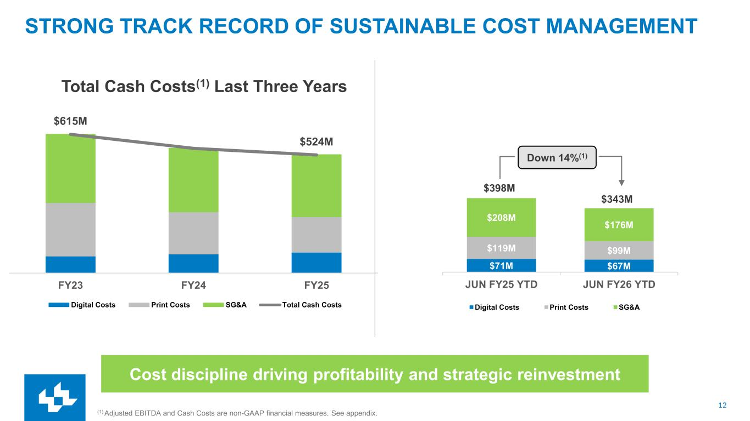
12 $71M $67M $119M $99M $208M $176M JUN FY25 YTD JUN FY26 YTD Digital Costs Print Costs SG&A STRONG TRACK RECORD OF SUSTAINABLE COST MANAGEMENT Cost discipline driving profitability and strategic reinvestment (1) Adjusted EBITDA and Cash Costs are non-GAAP financial measures. See appendix. Down 14%(1) $343M $398M $615M $524M FY23 FY24 FY25 Digital Costs Print Costs SG&A Total Cash Costs Total Cash Costs(1) Last Three Years

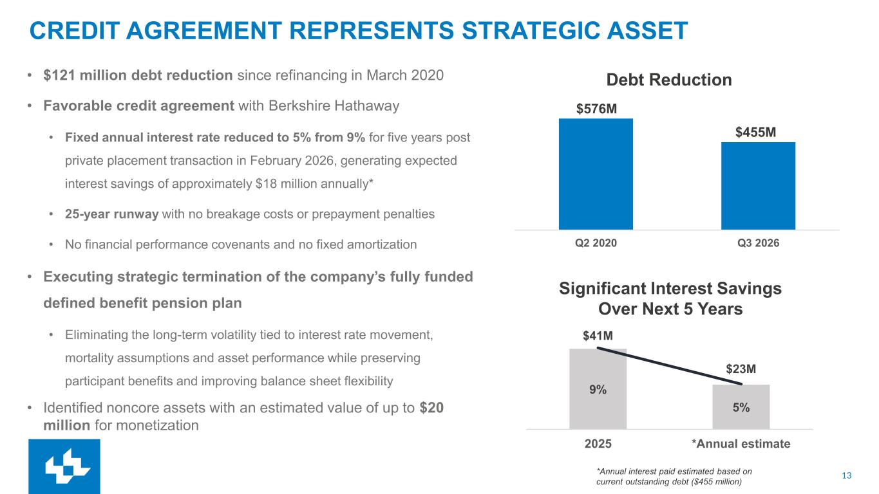
13 Q2 2020 Q3 2026 CREDIT AGREEMENT REPRESENTS STRATEGIC ASSET • $121 million debt reduction since refinancing in March 2020 • Favorable credit agreement with Berkshire Hathaway • Fixed annual interest rate reduced to 5% from 9% for five years post private placement transaction in February 2026, generating expected interest savings of approximately $18 million annually* • 25-year runway with no breakage costs or prepayment penalties • No financial performance covenants and no fixed amortization • Executing strategic termination of the company’s fully funded defined benefit pension plan • Eliminating the long-term volatility tied to interest rate movement, mortality assumptions and asset performance while preserving participant benefits and improving balance sheet flexibility • Identified noncore assets with an estimated value of up to $20 million for monetization $576M $455M Debt Reduction Significant Interest Savings Over Next 5 Years *Annual interest paid estimated based on current outstanding debt ($455 million) 9% 5% $41M $23M 2025 *Annual estimate

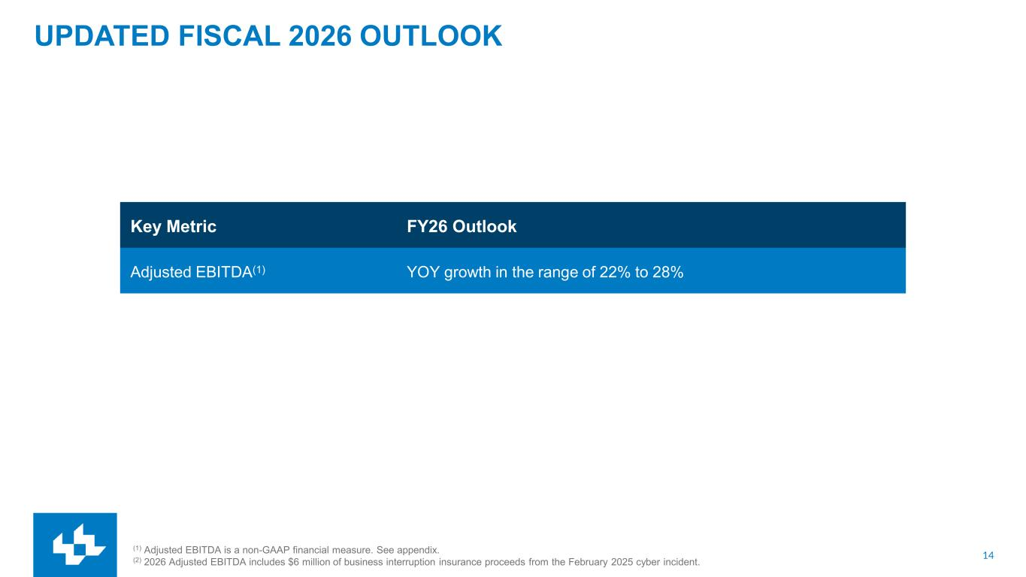
14 UPDATED FISCAL 2026 OUTLOOK (1) Adjusted EBITDA is a non-GAAP financial measure. See appendix. (2) 2026 Adjusted EBITDA includes $6 million of business interruption insurance proceeds from the February 2025 cyber incident. Key Metric FY26 Outlook Adjusted EBITDA(1) YOY growth in the range of 22% to 28%



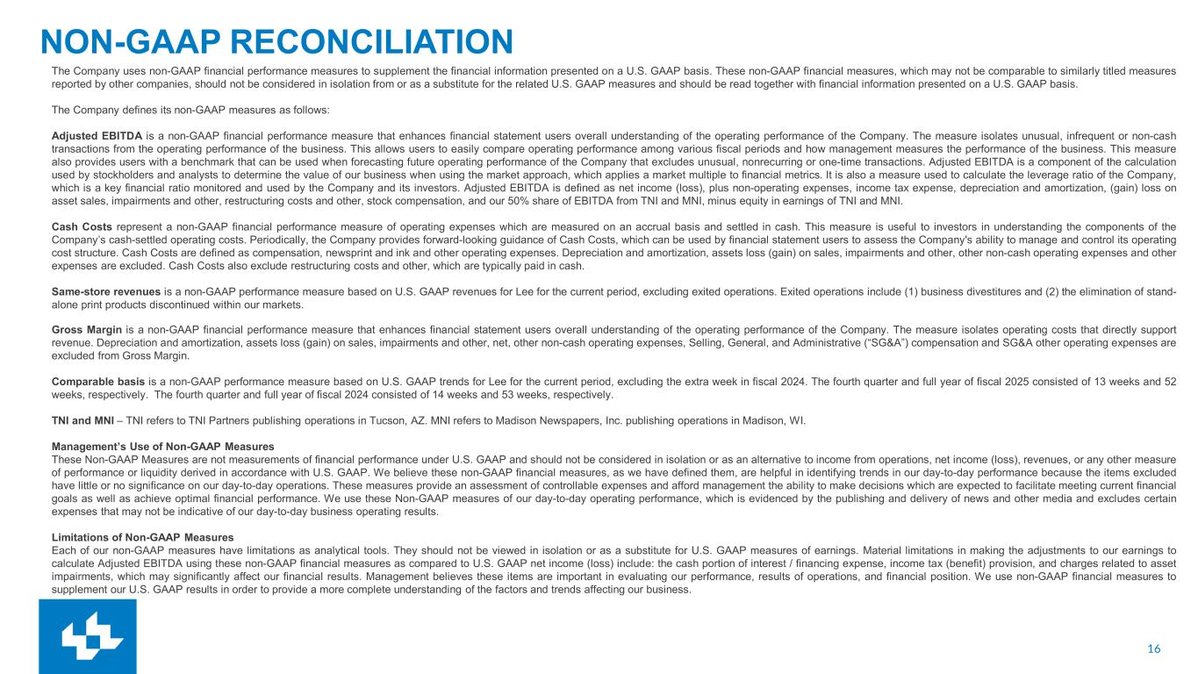
16 NON-GAAP RECONCILIATION The Company uses non-GAAP financial performance measures to supplement the financial information presented on a U.S. GAAP basis. These non-GAAP financial measures, which may not be comparable to similarly titled measures reported by other companies, should not be considered in isolation from or as a substitute for the related U.S. GAAP measures and should be read together with financial information presented on a U.S. GAAP basis. The Company defines its non-GAAP measures as follows: Adjusted EBITDA is a non-GAAP financial performance measure that enhances financial statement users overall understanding of the operating performance of the Company. The measure isolates unusual, infrequent or non-cash transactions from the operating performance of the business. This allows users to easily compare operating performance among various fiscal periods and how management measures the performance of the business. This measure also provides users with a benchmark that can be used when forecasting future operating performance of the Company that excludes unusual, nonrecurring or one-time transactions. Adjusted EBITDA is a component of the calculation used by stockholders and analysts to determine the value of our business when using the market approach, which applies a market multiple to financial metrics. It is also a measure used to calculate the leverage ratio of the Company, which is a key financial ratio monitored and used by the Company and its investors. Adjusted EBITDA is defined as net income (loss), plus non-operating expenses, income tax expense, depreciation and amortization, (gain) loss on asset sales, impairments and other, restructuring costs and other, stock compensation, and our 50% share of EBITDA from TNI and MNI, minus equity in earnings of TNI and MNI. Cash Costs represent a non-GAAP financial performance measure of operating expenses which are measured on an accrual basis and settled in cash. This measure is useful to investors in understanding the components of the Company’s cash-settled operating costs. Periodically, the Company provides forward-looking guidance of Cash Costs, which can be used by financial statement users to assess the Company's ability to manage and control its operating cost structure. Cash Costs are defined as compensation, newsprint and ink and other operating expenses. Depreciation and amortization, assets loss (gain) on sales, impairments and other, other non-cash operating expenses and other expenses are excluded. Cash Costs also exclude restructuring costs and other, which are typically paid in cash. Same-store revenues is a non-GAAP performance measure based on U.S. GAAP revenues for Lee for the current period, excluding exited operations. Exited operations include (1) business divestitures and (2) the elimination of stand- alone print products discontinued within our markets. Gross Margin is a non-GAAP financial performance measure that enhances financial statement users overall understanding of the operating performance of the Company. The measure isolates operating costs that directly support revenue. Depreciation and amortization, assets loss (gain) on sales, impairments and other, net, other non-cash operating expenses, Selling, General, and Administrative (“SG&A”) compensation and SG&A other operating expenses are excluded from Gross Margin. Comparable basis is a non-GAAP performance measure based on U.S. GAAP trends for Lee for the current period, excluding the extra week in fiscal 2024. The fourth quarter and full year of fiscal 2025 consisted of 13 weeks and 52 weeks, respectively. The fourth quarter and full year of fiscal 2024 consisted of 14 weeks and 53 weeks, respectively. TNI and MNI – TNI refers to TNI Partners publishing operations in Tucson, AZ. MNI refers to Madison Newspapers, Inc. publishing operations in Madison, WI. Management’s Use of Non-GAAP Measures These Non-GAAP Measures are not measurements of financial performance under U.S. GAAP and should not be considered in isolation or as an alternative to income from operations, net income (loss), revenues, or any other measure of performance or liquidity derived in accordance with U.S. GAAP. We believe these non-GAAP financial measures, as we have defined them, are helpful in identifying trends in our day-to-day performance because the items excluded have little or no significance on our day-to-day operations. These measures provide an assessment of controllable expenses and afford management the ability to make decisions which are expected to facilitate meeting current financial goals as well as achieve optimal financial performance. We use these Non-GAAP measures of our day-to-day operating performance, which is evidenced by the publishing and delivery of news and other media and excludes certain expenses that may not be indicative of our day-to-day business operating results. Limitations of Non-GAAP Measures Each of our non-GAAP measures have limitations as analytical tools. They should not be viewed in isolation or as a substitute for U.S. GAAP measures of earnings. Material limitations in making the adjustments to our earnings to calculate Adjusted EBITDA using these non-GAAP financial measures as compared to U.S. GAAP net income (loss) include: the cash portion of interest / financing expense, income tax (benefit) provision, and charges related to asset impairments, which may significantly affect our financial results. Management believes these items are important in evaluating our performance, results of operations, and financial position. We use non-GAAP financial measures to supplement our U.S. GAAP results in order to provide a more complete understanding of the factors and trends affecting our business.

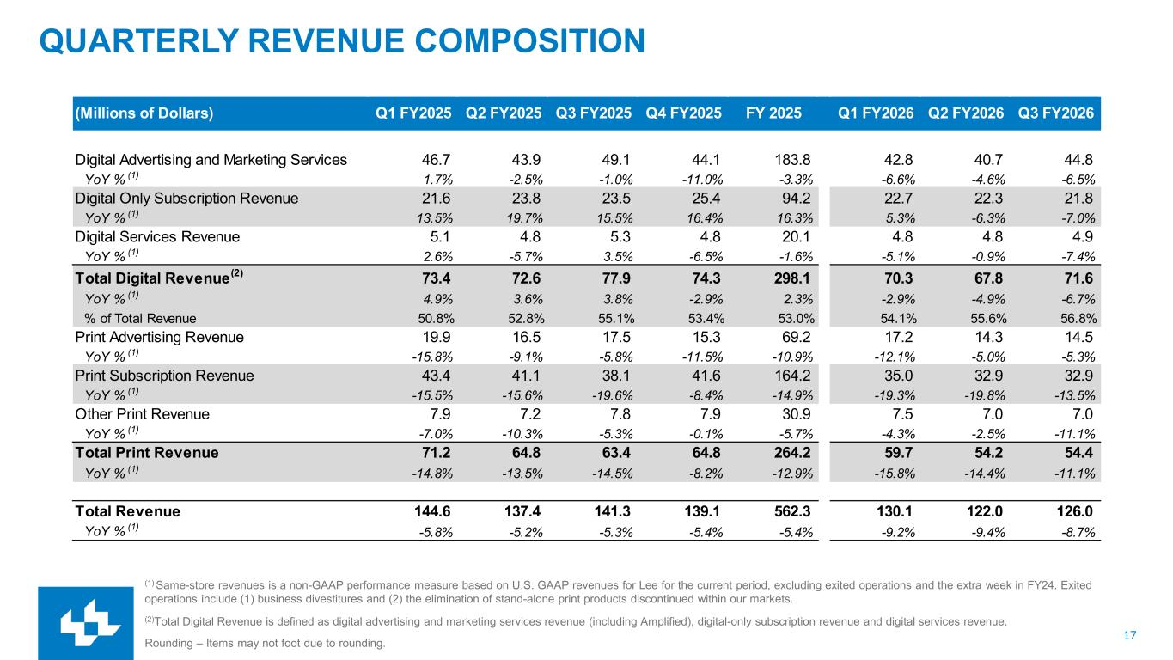
17 QUARTERLY REVENUE COMPOSITION (1) Same-store revenues is a non-GAAP performance measure based on U.S. GAAP revenues for Lee for the current period, excluding exited operations and the extra week in FY24. Exited operations include (1) business divestitures and (2) the elimination of stand-alone print products discontinued within our markets. (2)Total Digital Revenue is defined as digital advertising and marketing services revenue (including Amplified), digital-only subscription revenue and digital services revenue. Rounding – Items may not foot due to rounding. (Millions of Dollars) Q1 FY2025 Q2 FY2025 Q3 FY2025 Q4 FY2025 FY 2025 Q1 FY2026 Q2 FY2026 Q3 FY2026 Digital Advertising and Marketing Services 46.7 43.9 49.1 44.1 183.8 42.8 40.7 44.8 YoY % (1) 1.7% -2.5% -1.0% -11.0% -3.3% -6.6% -4.6% -6.5% Digital Only Subscription Revenue 21.6 23.8 23.5 25.4 94.2 22.7 22.3 21.8 YoY % (1) 13.5% 19.7% 15.5% 16.4% 16.3% 5.3% -6.3% -7.0% Digital Services Revenue 5.1 4.8 5.3 4.8 20.1 4.8 4.8 4.9 YoY % (1) 2.6% -5.7% 3.5% -6.5% -1.6% -5.1% -0.9% -7.4% Total Digital Revenue(2) 73.4 72.6 77.9 74.3 298.1 70.3 67.8 71.6 YoY % (1) 4.9% 3.6% 3.8% -2.9% 2.3% -2.9% -4.9% -6.7% % of Total Revenue 50.8% 52.8% 55.1% 53.4% 53.0% 54.1% 55.6% 56.8% Print Advertising Revenue 19.9 16.5 17.5 15.3 69.2 17.2 14.3 14.5 YoY % (1) -15.8% -9.1% -5.8% -11.5% -10.9% -12.1% -5.0% -5.3% Print Subscription Revenue 43.4 41.1 38.1 41.6 164.2 35.0 32.9 32.9 YoY % (1) -15.5% -15.6% -19.6% -8.4% -14.9% -19.3% -19.8% -13.5% Other Print Revenue 7.9 7.2 7.8 7.9 30.9 7.5 7.0 7.0 YoY % (1) -7.0% -10.3% -5.3% -0.1% -5.7% -4.3% -2.5% -11.1% Total Print Revenue 71.2 64.8 63.4 64.8 264.2 59.7 54.2 54.4 YoY % (1) -14.8% -13.5% -14.5% -8.2% -12.9% -15.8% -14.4% -11.1% Total Revenue 144.6 137.4 141.3 139.1 562.3 130.1 122.0 126.0 YoY % (1) -5.8% -5.2% -5.3% -5.4% -5.4% -9.2% -9.4% -8.7%

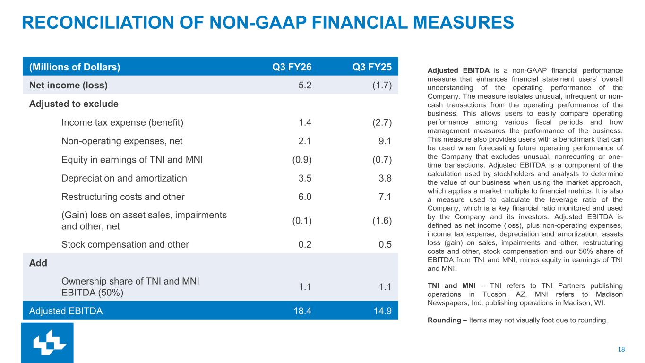
18 RECONCILIATION OF NON-GAAP FINANCIAL MEASURES (Millions of Dollars) Q3 FY26 Q3 FY25 Net income (loss) 5.2 (1.7) Adjusted to exclude Income tax expense (benefit) 1.4 (2.7) Non-operating expenses, net 2.1 9.1 Equity in earnings of TNI and MNI (0.9) (0.7) Depreciation and amortization 3.5 3.8 Restructuring costs and other 6.0 7.1 (Gain) loss on asset sales, impairments and other, net (0.1) (1.6) Stock compensation and other 0.2 0.5 Add Ownership share of TNI and MNI EBITDA (50%) 1.1 1.1 Adjusted EBITDA 18.4 14.9 Adjusted EBITDA is a non-GAAP financial performance measure that enhances financial statement users’ overall understanding of the operating performance of the Company. The measure isolates unusual, infrequent or non- cash transactions from the operating performance of the business. This allows users to easily compare operating performance among various fiscal periods and how management measures the performance of the business. This measure also provides users with a benchmark that can be used when forecasting future operating performance of the Company that excludes unusual, nonrecurring or one- time transactions. Adjusted EBITDA is a component of the calculation used by stockholders and analysts to determine the value of our business when using the market approach, which applies a market multiple to financial metrics. It is also a measure used to calculate the leverage ratio of the Company, which is a key financial ratio monitored and used by the Company and its investors. Adjusted EBITDA is defined as net income (loss), plus non-operating expenses, income tax expense, depreciation and amortization, assets loss (gain) on sales, impairments and other, restructuring costs and other, stock compensation and our 50% share of EBITDA from TNI and MNI, minus equity in earnings of TNI and MNI. TNI and MNI – TNI refers to TNI Partners publishing operations in Tucson, AZ. MNI refers to Madison Newspapers, Inc. publishing operations in Madison, WI. Rounding – Items may not visually foot due to rounding.

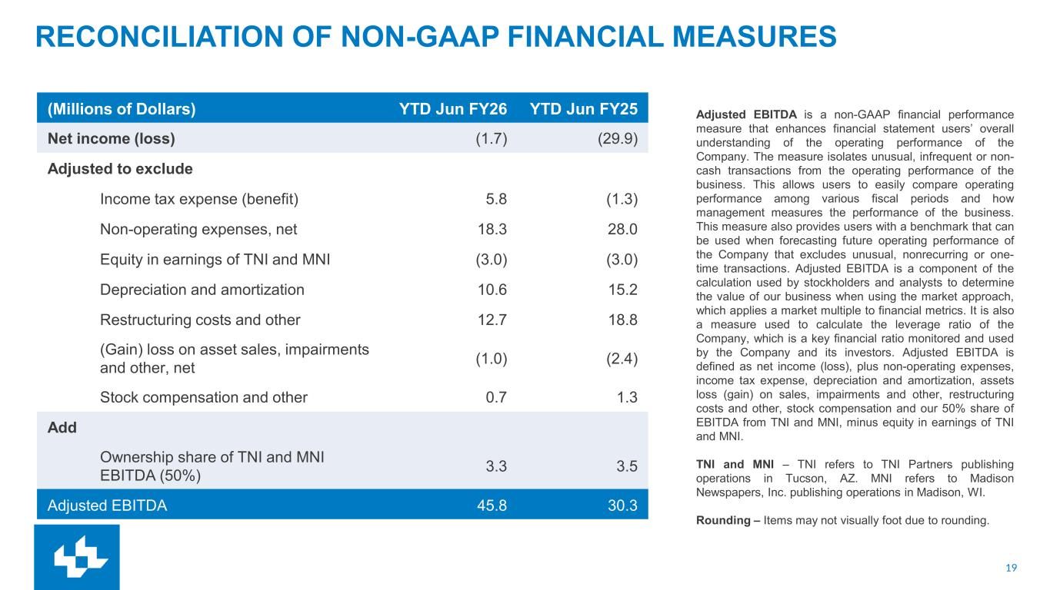
19 RECONCILIATION OF NON-GAAP FINANCIAL MEASURES Adjusted EBITDA is a non-GAAP financial performance measure that enhances financial statement users’ overall understanding of the operating performance of the Company. The measure isolates unusual, infrequent or non- cash transactions from the operating performance of the business. This allows users to easily compare operating performance among various fiscal periods and how management measures the performance of the business. This measure also provides users with a benchmark that can be used when forecasting future operating performance of the Company that excludes unusual, nonrecurring or one- time transactions. Adjusted EBITDA is a component of the calculation used by stockholders and analysts to determine the value of our business when using the market approach, which applies a market multiple to financial metrics. It is also a measure used to calculate the leverage ratio of the Company, which is a key financial ratio monitored and used by the Company and its investors. Adjusted EBITDA is defined as net income (loss), plus non-operating expenses, income tax expense, depreciation and amortization, assets loss (gain) on sales, impairments and other, restructuring costs and other, stock compensation and our 50% share of EBITDA from TNI and MNI, minus equity in earnings of TNI and MNI. TNI and MNI – TNI refers to TNI Partners publishing operations in Tucson, AZ. MNI refers to Madison Newspapers, Inc. publishing operations in Madison, WI. Rounding – Items may not visually foot due to rounding. (Millions of Dollars) YTD Jun FY26 YTD Jun FY25 Net income (loss) (1.7) (29.9) Adjusted to exclude Income tax expense (benefit) 5.8 (1.3) Non-operating expenses, net 18.3 28.0 Equity in earnings of TNI and MNI (3.0) (3.0) Depreciation and amortization 10.6 15.2 Restructuring costs and other 12.7 18.8 (Gain) loss on asset sales, impairments and other, net (1.0) (2.4) Stock compensation and other 0.7 1.3 Add Ownership share of TNI and MNI EBITDA (50%) 3.3 3.5 Adjusted EBITDA 45.8 30.3

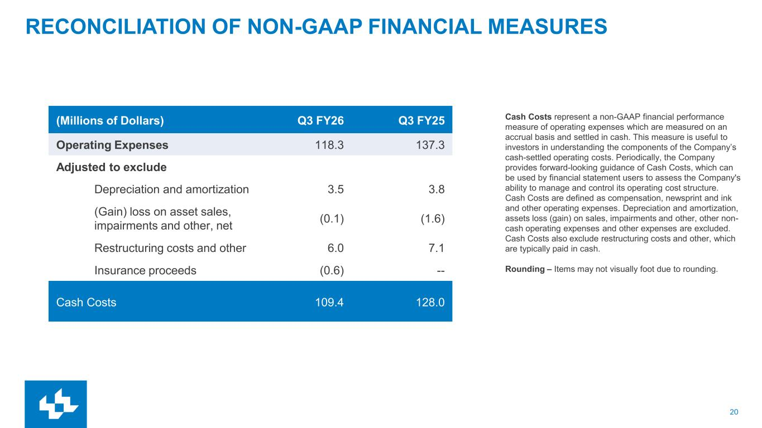
20 RECONCILIATION OF NON-GAAP FINANCIAL MEASURES Cash Costs represent a non-GAAP financial performance measure of operating expenses which are measured on an accrual basis and settled in cash. This measure is useful to investors in understanding the components of the Company’s cash-settled operating costs. Periodically, the Company provides forward-looking guidance of Cash Costs, which can be used by financial statement users to assess the Company's ability to manage and control its operating cost structure. Cash Costs are defined as compensation, newsprint and ink and other operating expenses. Depreciation and amortization, assets loss (gain) on sales, impairments and other, other non- cash operating expenses and other expenses are excluded. Cash Costs also exclude restructuring costs and other, which are typically paid in cash. Rounding – Items may not visually foot due to rounding. (Millions of Dollars) Q3 FY26 Q3 FY25 Operating Expenses 118.3 137.3 Adjusted to exclude Depreciation and amortization 3.5 3.8 (Gain) loss on asset sales, impairments and other, net (0.1) (1.6) Restructuring costs and other 6.0 7.1 Insurance proceeds (0.6) -- Cash Costs 109.4 128.0

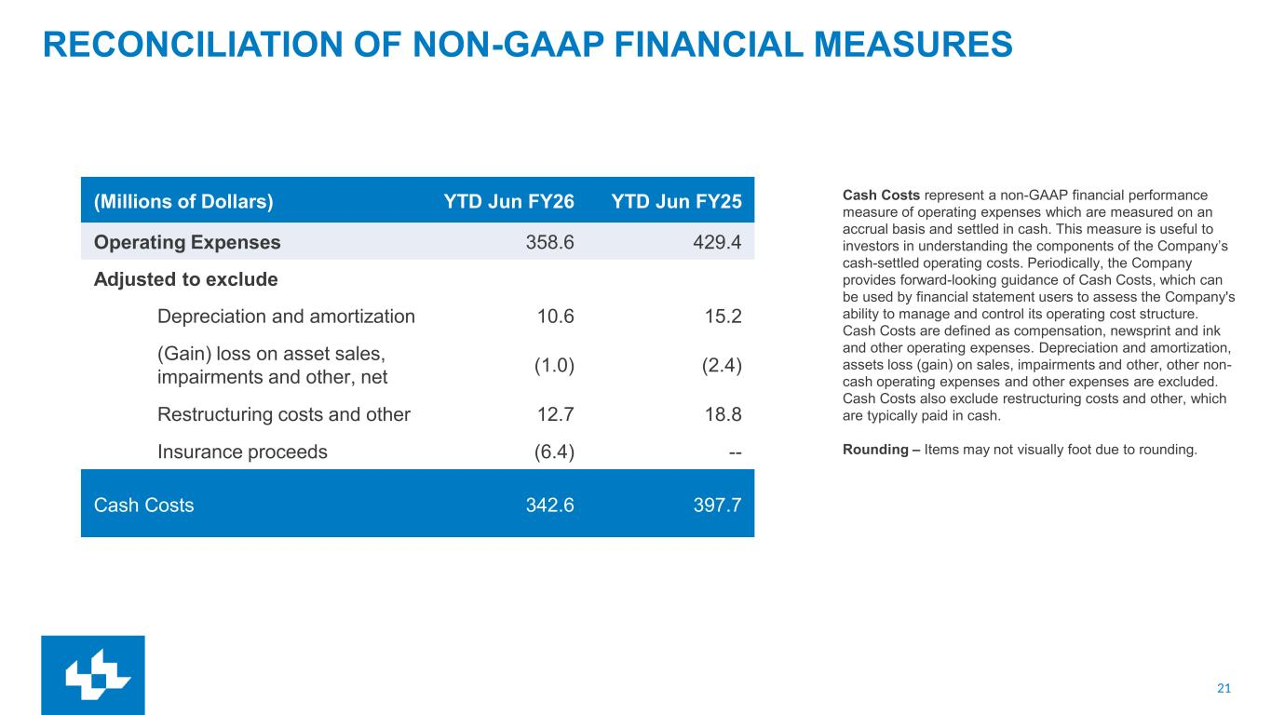
21 RECONCILIATION OF NON-GAAP FINANCIAL MEASURES Cash Costs represent a non-GAAP financial performance measure of operating expenses which are measured on an accrual basis and settled in cash. This measure is useful to investors in understanding the components of the Company’s cash-settled operating costs. Periodically, the Company provides forward-looking guidance of Cash Costs, which can be used by financial statement users to assess the Company's ability to manage and control its operating cost structure. Cash Costs are defined as compensation, newsprint and ink and other operating expenses. Depreciation and amortization, assets loss (gain) on sales, impairments and other, other non- cash operating expenses and other expenses are excluded. Cash Costs also exclude restructuring costs and other, which are typically paid in cash. Rounding – Items may not visually foot due to rounding. (Millions of Dollars) YTD Jun FY26 YTD Jun FY25 Operating Expenses 358.6 429.4 Adjusted to exclude Depreciation and amortization 10.6 15.2 (Gain) loss on asset sales, impairments and other, net (1.0) (2.4) Restructuring costs and other 12.7 18.8 Insurance proceeds (6.4) -- Cash Costs 342.6 397.7

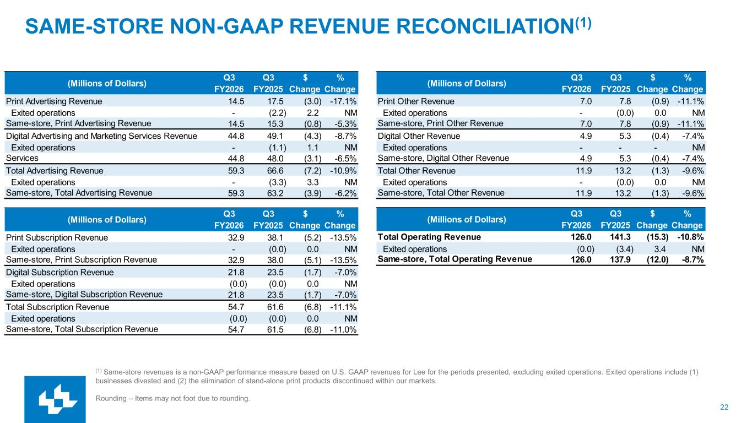
22 SAME-STORE NON-GAAP REVENUE RECONCILIATION(1) (1) Same-store revenues is a non-GAAP performance measure based on U.S. GAAP revenues for Lee for the periods presented, excluding exited operations. Exited operations include (1) businesses divested and (2) the elimination of stand-alone print products discontinued within our markets. Rounding – Items may not foot due to rounding. (Millions of Dollars) Q3 FY2026 Q3 FY2025 $ Change % Change Print Advertising Revenue 14.5 17.5 (3.0) -17.1% Exited operations - (2.2) 2.2 NM Same-store, Print Advertising Revenue 14.5 15.3 (0.8) -5.3% Digital Advertising and Marketing Services Revenue 44.8 49.1 (4.3) -8.7% Exited operations - (1.1) 1.1 NMSam -stor , Digital Advertising and Marketing Services 44.8 48.0 (3.1) -6.5% Total Advertising Revenue 59.3 66.6 (7.2) -10.9% Exited operations - (3.3) 3.3 NM Same-store, Total Advertising Revenue 59.3 63.2 (3.9) -6.2% (Millions of Dollars) Q3 FY2026 Q3 FY2025 $ Change % Change Print Subscription Revenue 32.9 38.1 (5.2) -13.5% Exited operations - (0.0) 0.0 NM Same-store, Print Subscription Revenue 32.9 38.0 (5.1) -13.5% Digital Subscription Revenue 21.8 23.5 (1.7) -7.0% Exited operations (0.0) (0.0) 0.0 NM Same-store, Digital Subscription Revenue 21.8 23.5 (1.7) -7.0% Total Subscription Revenue 54.7 61.6 (6.8) -11.1% Exited operations (0.0) (0.0) 0.0 NM Same-store, Total Subscription Revenue 54.7 61.5 (6.8) -11.0% (Millions of Dollars) Q3 FY2026 Q3 FY2025 $ Change % Change Print Other Revenue 7.0 7.8 (0.9) -11.1% Exited operations - (0.0) 0.0 NM Same-store, Print Other Revenue 7.0 7.8 (0.9) -11.1% Digital Other Revenue 4.9 5.3 (0.4) -7.4% Exited operations - - - NM Same-store, Digital Other Revenue 4.9 5.3 (0.4) -7.4% Total Other Revenue 11.9 13.2 (1.3) -9.6% Exited operations - (0.0) 0.0 NM Same-store, Total Other Revenue 11.9 13.2 (1.3) -9.6% (Millions of Dollars) Q3 FY2026 Q3 FY2025 $ Change % Change Total Operating Revenue 126.0 141.3 (15.3) -10.8% Exited operations (0.0) (3.4) 3.4 NM Same-store, Total Operating Revenue 126.0 137.9 (12.0) -8.7%

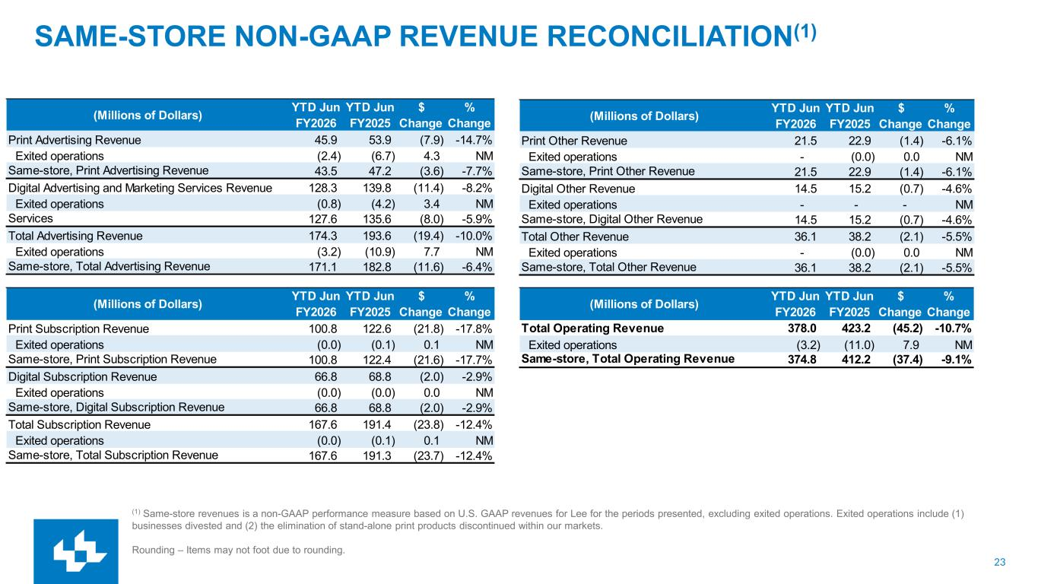
23 SAME-STORE NON-GAAP REVENUE RECONCILIATION(1) (1) Same-store revenues is a non-GAAP performance measure based on U.S. GAAP revenues for Lee for the periods presented, excluding exited operations. Exited operations include (1) businesses divested and (2) the elimination of stand-alone print products discontinued within our markets. Rounding – Items may not foot due to rounding. (Millions of Dollars) YTD Jun FY2026 YTD Jun FY2025 $ Change % Change Print Advertising Revenue 45.9 53.9 (7.9) -14.7% Exited operations (2.4) (6.7) 4.3 NM Same-store, Print Advertising Revenue 43.5 47.2 (3.6) -7.7% Digital Advertising and Marketing Services Revenue 128.3 139.8 (11.4) -8.2% Exited operations (0.8) (4.2) 3.4 NMSam -stor , Digital Advertising and Marketing Services 127.6 135.6 (8.0) -5.9% Total Advertising Revenue 174.3 193.6 (19.4) -10.0% Exited operations (3.2) (10.9) 7.7 NM Same-store, Total Advertising Revenue 171.1 182.8 (11.6) -6.4% (Millions of Dollars) YTD Jun FY2026 YTD Jun FY2025 $ Change % Change Print Subscription Revenue 100.8 122.6 (21.8) -17.8% Exited operations (0.0) (0.1) 0.1 NM Same-store, Print Subscription Revenue 100.8 122.4 (21.6) -17.7% Digital Subscription Revenue 66.8 68.8 (2.0) -2.9% Exited operations (0.0) (0.0) 0.0 NM Same-store, Digital Subscription Revenue 66.8 68.8 (2.0) -2.9% Total Subscription Revenue 167.6 191.4 (23.8) -12.4% Exited operations (0.0) (0.1) 0.1 NM Same-store, Total Subscription Revenue 167.6 191.3 (23.7) -12.4% (Millions of Dollars) YTD Jun FY2026 YTD Jun FY2025 $ Change % Change Print Other Revenue 21.5 22.9 (1.4) -6.1% Exited operations - (0.0) 0.0 NM Same-store, Print Other Revenue 21.5 22.9 (1.4) -6.1% Digital Other Revenue 14.5 15.2 (0.7) -4.6% Exited operations - - - NM Same-store, Digital Other Revenue 14.5 15.2 (0.7) -4.6% Total Other Revenue 36.1 38.2 (2.1) -5.5% Exited operations - (0.0) 0.0 NM Same-store, Total Other Revenue 36.1 38.2 (2.1) -5.5% (Millions of Dollars) YTD Jun FY2026 YTD Jun FY2025 $ Change % Change Total Operating Revenue 378.0 423.2 (45.2) -10.7% Exited operations (3.2) (11.0) 7.9 NM Same-store, Total Operating Revenue 374.8 412.2 (37.4) -9.1%

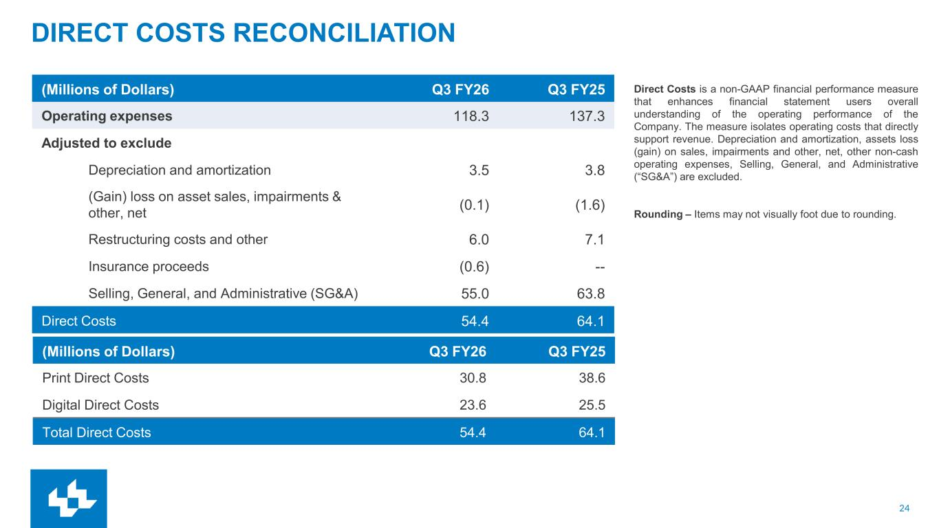
24 DIRECT COSTS RECONCILIATION (Millions of Dollars) Q3 FY26 Q3 FY25 Operating expenses 118.3 137.3 Adjusted to exclude Depreciation and amortization 3.5 3.8 (Gain) loss on asset sales, impairments & other, net (0.1) (1.6) Restructuring costs and other 6.0 7.1 Insurance proceeds (0.6) -- Selling, General, and Administrative (SG&A) 55.0 63.8 Direct Costs 54.4 64.1 Direct Costs is a non-GAAP financial performance measure that enhances financial statement users overall understanding of the operating performance of the Company. The measure isolates operating costs that directly support revenue. Depreciation and amortization, assets loss (gain) on sales, impairments and other, net, other non-cash operating expenses, Selling, General, and Administrative (“SG&A”) are excluded. Rounding – Items may not visually foot due to rounding. (Millions of Dollars) Q3 FY26 Q3 FY25 Print Direct Costs 30.8 38.6 Digital Direct Costs 23.6 25.5 Total Direct Costs 54.4 64.1

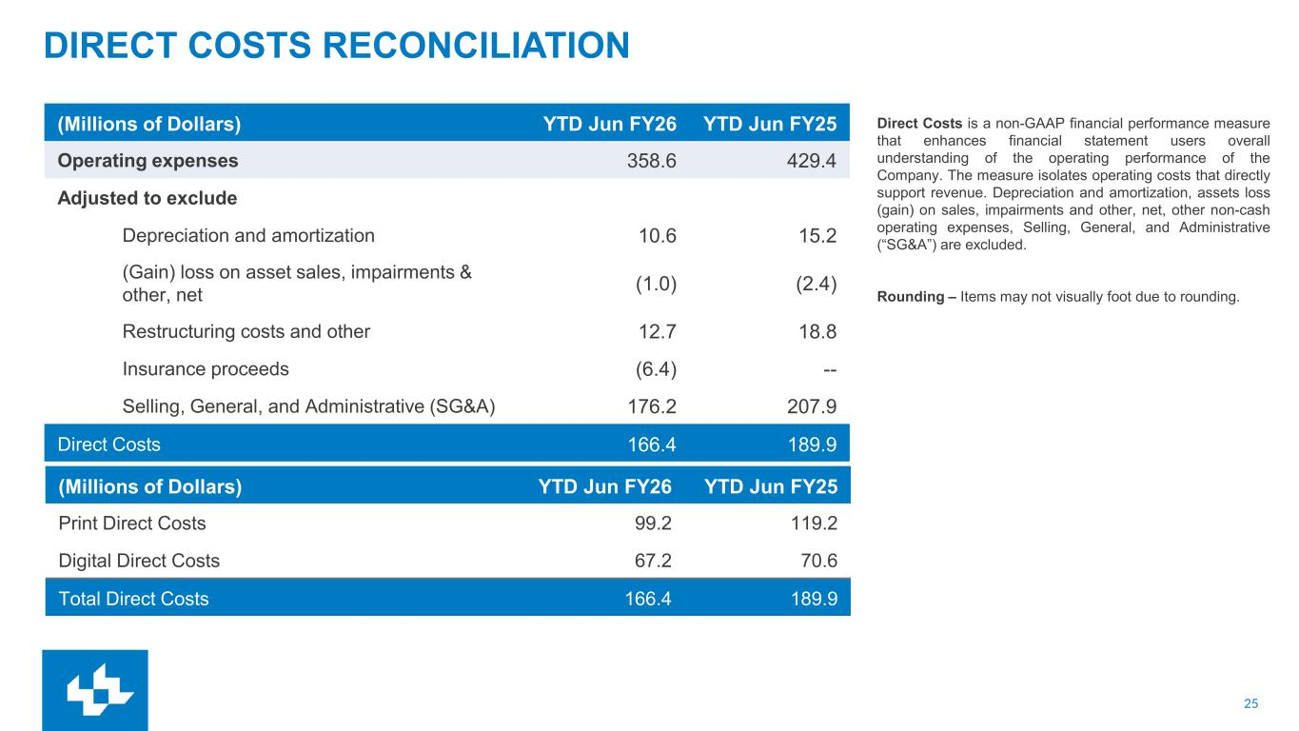
25 DIRECT COSTS RECONCILIATION (Millions of Dollars) YTD Jun FY26 YTD Jun FY25 Operating expenses 358.6 429.4 Adjusted to exclude Depreciation and amortization 10.6 15.2 (Gain) loss on asset sales, impairments & other, net (1.0) (2.4) Restructuring costs and other 12.7 18.8 Insurance proceeds (6.4) -- Selling, General, and Administrative (SG&A) 176.2 207.9 Direct Costs 166.4 189.9 Direct Costs is a non-GAAP financial performance measure that enhances financial statement users overall understanding of the operating performance of the Company. The measure isolates operating costs that directly support revenue. Depreciation and amortization, assets loss (gain) on sales, impairments and other, net, other non-cash operating expenses, Selling, General, and Administrative (“SG&A”) are excluded. Rounding – Items may not visually foot due to rounding. (Millions of Dollars) YTD Jun FY26 YTD Jun FY25 Print Direct Costs 99.2 119.2 Digital Direct Costs 67.2 70.6 Total Direct Costs 166.4 189.9

